Identity@Lloyd’s

Contents:

How to register as a new user
Requesting access to additional applications
Administrator access
Suspending your account
Deleting your account
User profile
Passwords

Note: Currently only access to Core Market Returns, CMR Offline Validator and the Overseas Reporting applications can be requested through Identity@Lloyd’s. Other applications will be available in due course.

How to register as a new user
Go to Lloyds.com and select Login/register from the menu or via URL. In the login screen that appears select Register:

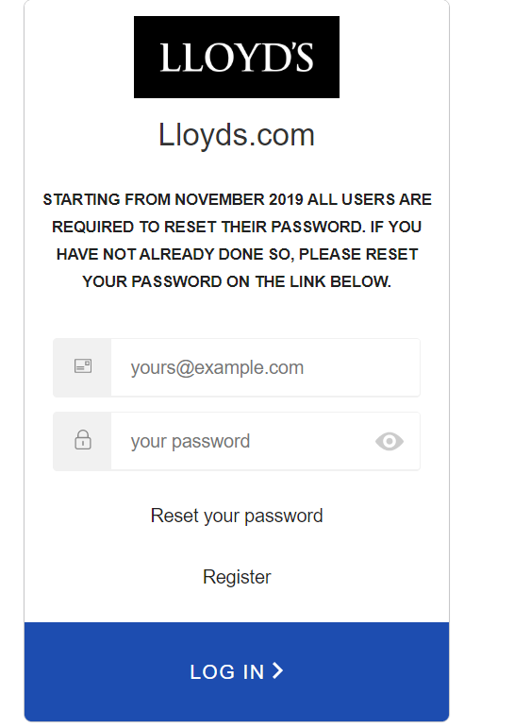

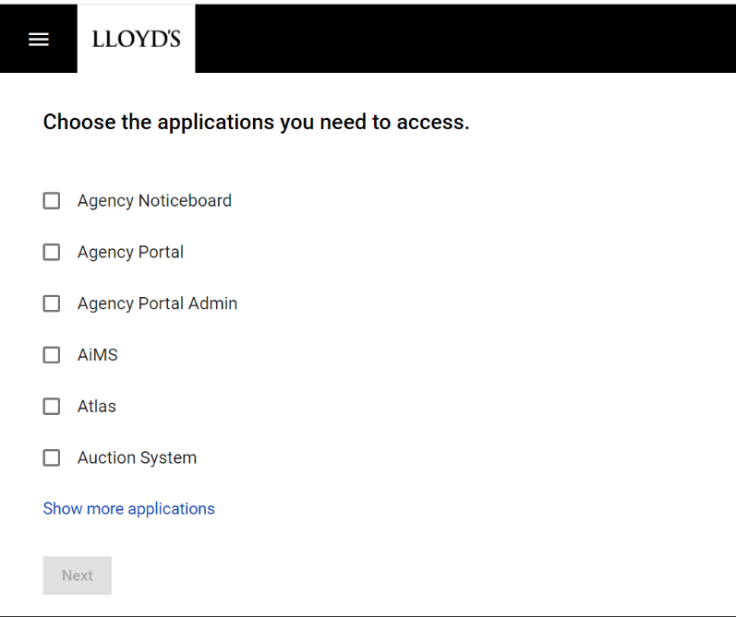
You should be presented with a screen showing a list of applications.
Select the application(s) that you would like access to by clicking the checkbox by the application name. The list can be expanded by clicking ‘Show more applications’.

Click on the ‘Next’ button to progress with your registration.

The next screen requires you to enter your details. All fields on this screen are mandatory. A valid email address must be entered as your verification and password setting emails will be sent to this address.
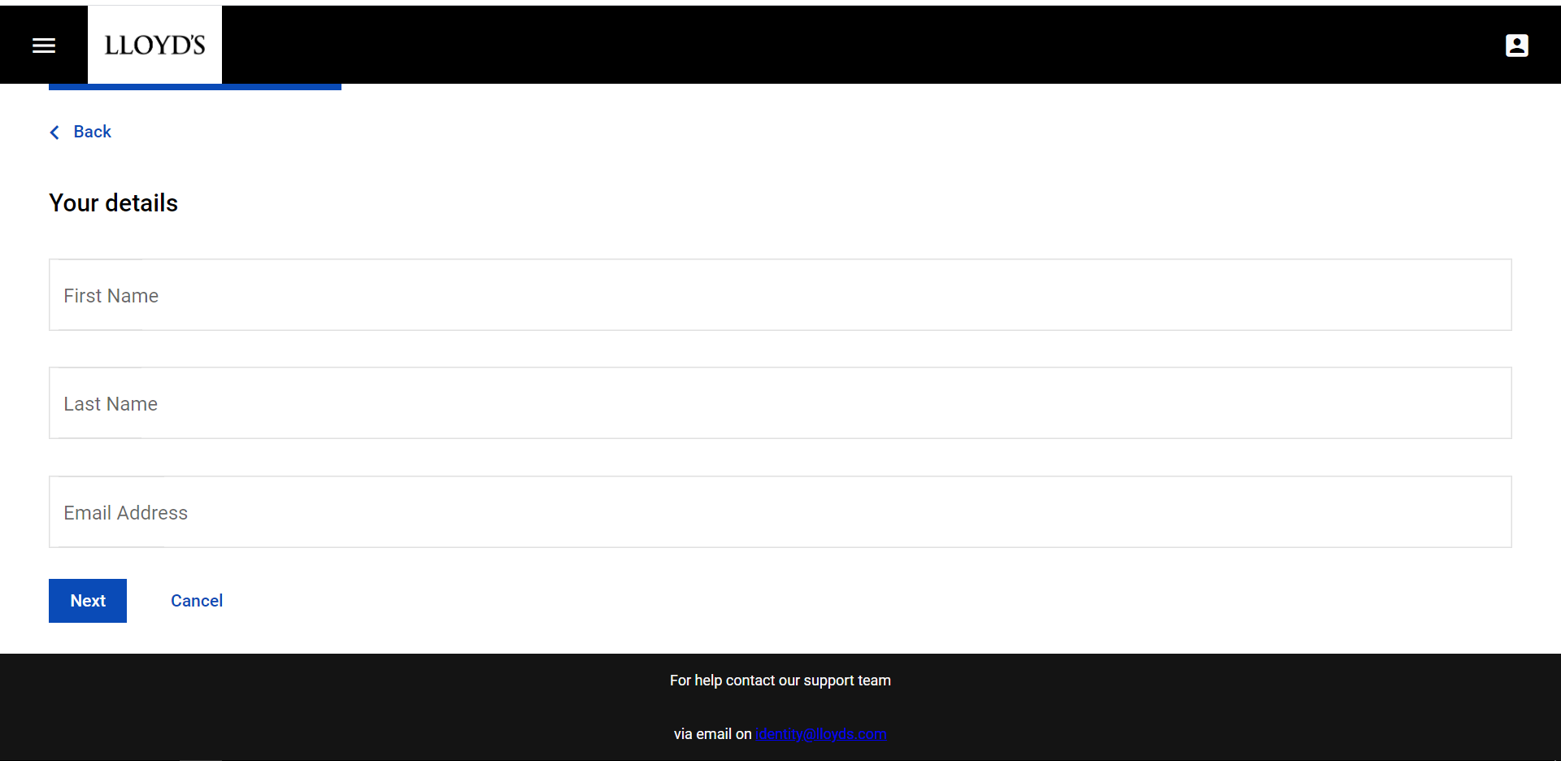
Once you have completed all the fields, click ‘Next’ to proceed with your request

The next screen captures details of your organisation.
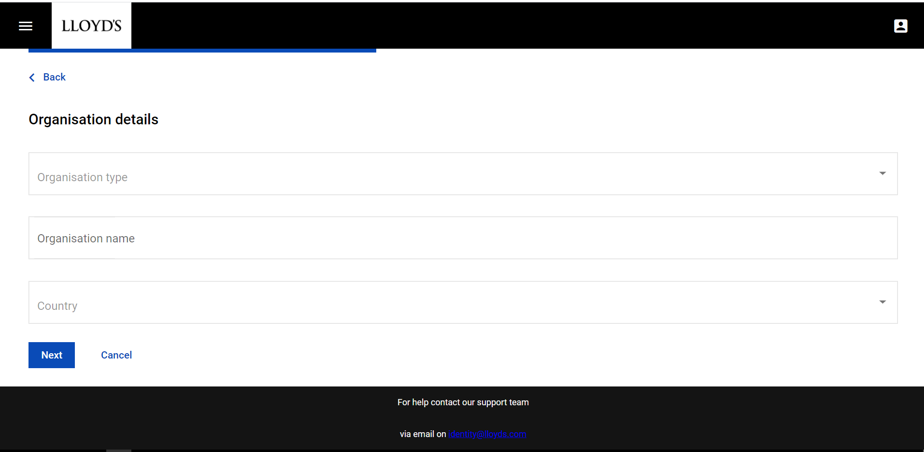
Select your ‘Organisation type’ from the drop-down list. Manually enter your ‘Organisation name’ and select the ‘Country’ location from the drop-down list. Once again, all the fields on this screen must be completed. Click ‘Next’ to proceed with your access request.

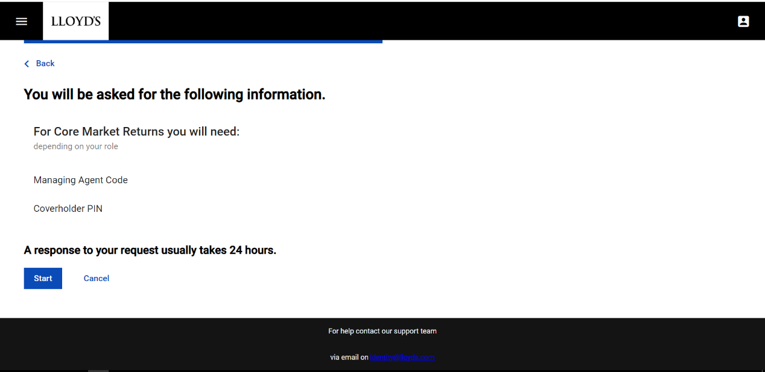
The next screen will display the additional information you will need to complete your request depending on the application(s) you are requesting access to. If you are requesting access to multiple applications, each additional requirement will be listed on this screen.

Once you have gathered all the additional information for your request, click ‘Start’, Identity@Lloyd’s will then present the information screen appropriate to the application(s) you have requested access to.
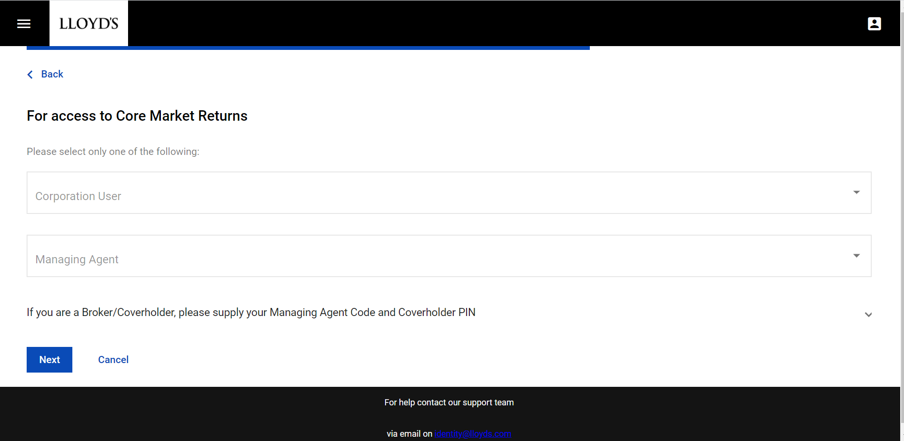
Once you have completed the required information, click ‘Next’ to progress to the next screen. If you have requested access to more than one system, this screen will be repeated until all the information required by each application has been provided.

After the final information screen has been completed, Identity@Lloyd’s will show a screen summarising your request. Check all the information you have entered is correct and click on the ‘Send Request’ button.
Your request(s) will be sent to the appropriate administrator(s) for review. You will receive an email notifying you of the outcome once your request has been reviewed.

You will also receive several emails as follows:
- A request verification email – click on the link within 24-hours to confirm your email address. This needs to be done before you can access any of the applications requested.
- A password reset email – click on the link to go to the password reset screen and enter a password of your choice.
- Emails confirming each application request you made

Requesting access to additional applications
If you need access to additional applications other than those you already have, you can do this via your Identity@Lloyd’s profile. Access your profile either by logging in to Identity@Lloyd’s or selecting ‘Profile’ from the menu if you are already logged in.
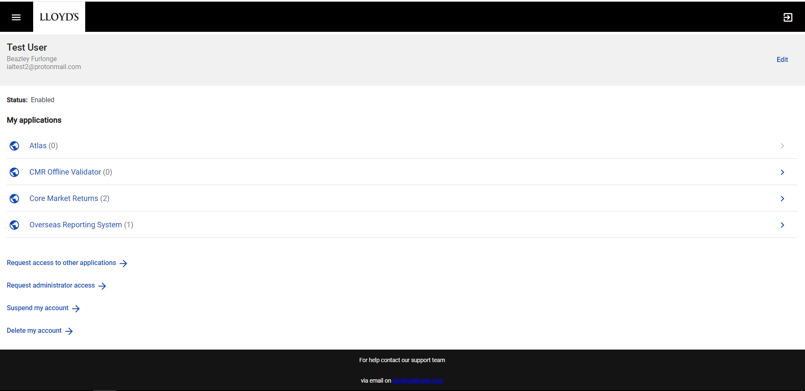
Click the ‘Request access to other applications’ button, this should display the application list. Follow the steps above in the ‘How to register a new user’ section as they are the same.

Administrator access
Administrator access is only available for applications that you already have user access for. Access can either be requested by you, via the ‘Request administrator access’ button, or given by an administrator or application owner.

Suspending your account
Suspending your account means that you will not have access to your applications for period of time which may cover extended leave from work, secondments or other instances when your access isn’t needed but will be needed again in the future.

Access your profile either by logging in to Identity@Lloyd’s or selecting ‘Profile’ from the menu if you are already logged in.
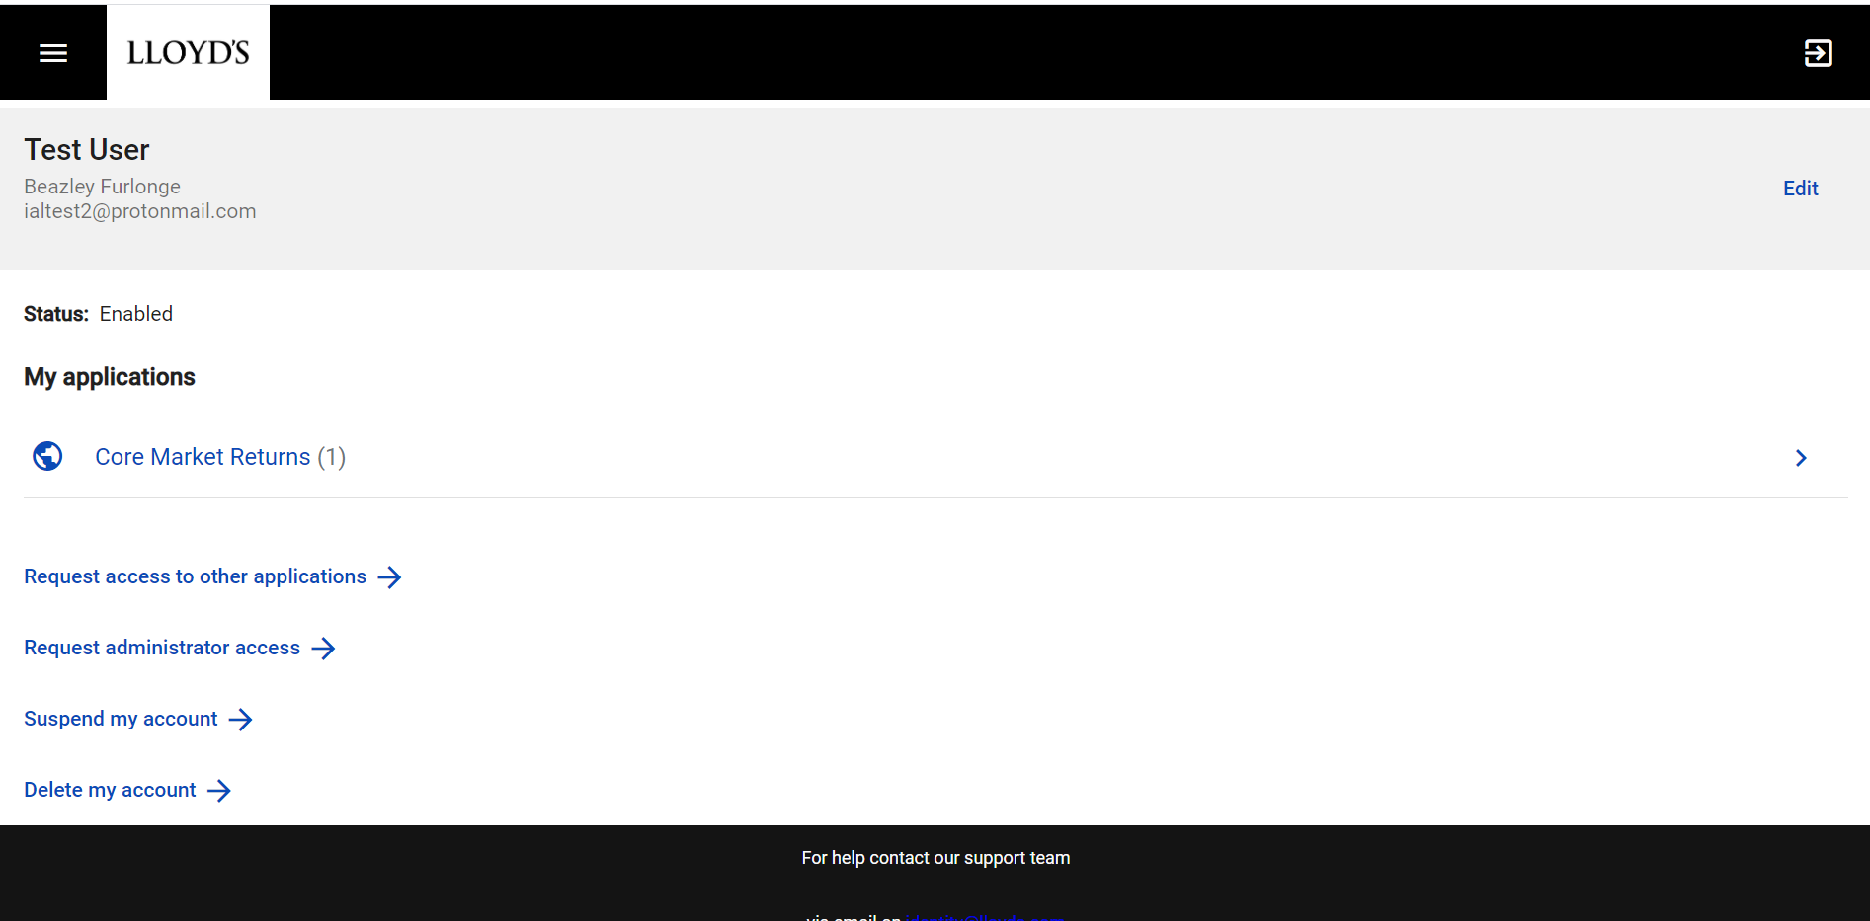

Click the ‘Suspend my account’ button, this should display a confirmation screen displaying the access you will suspend
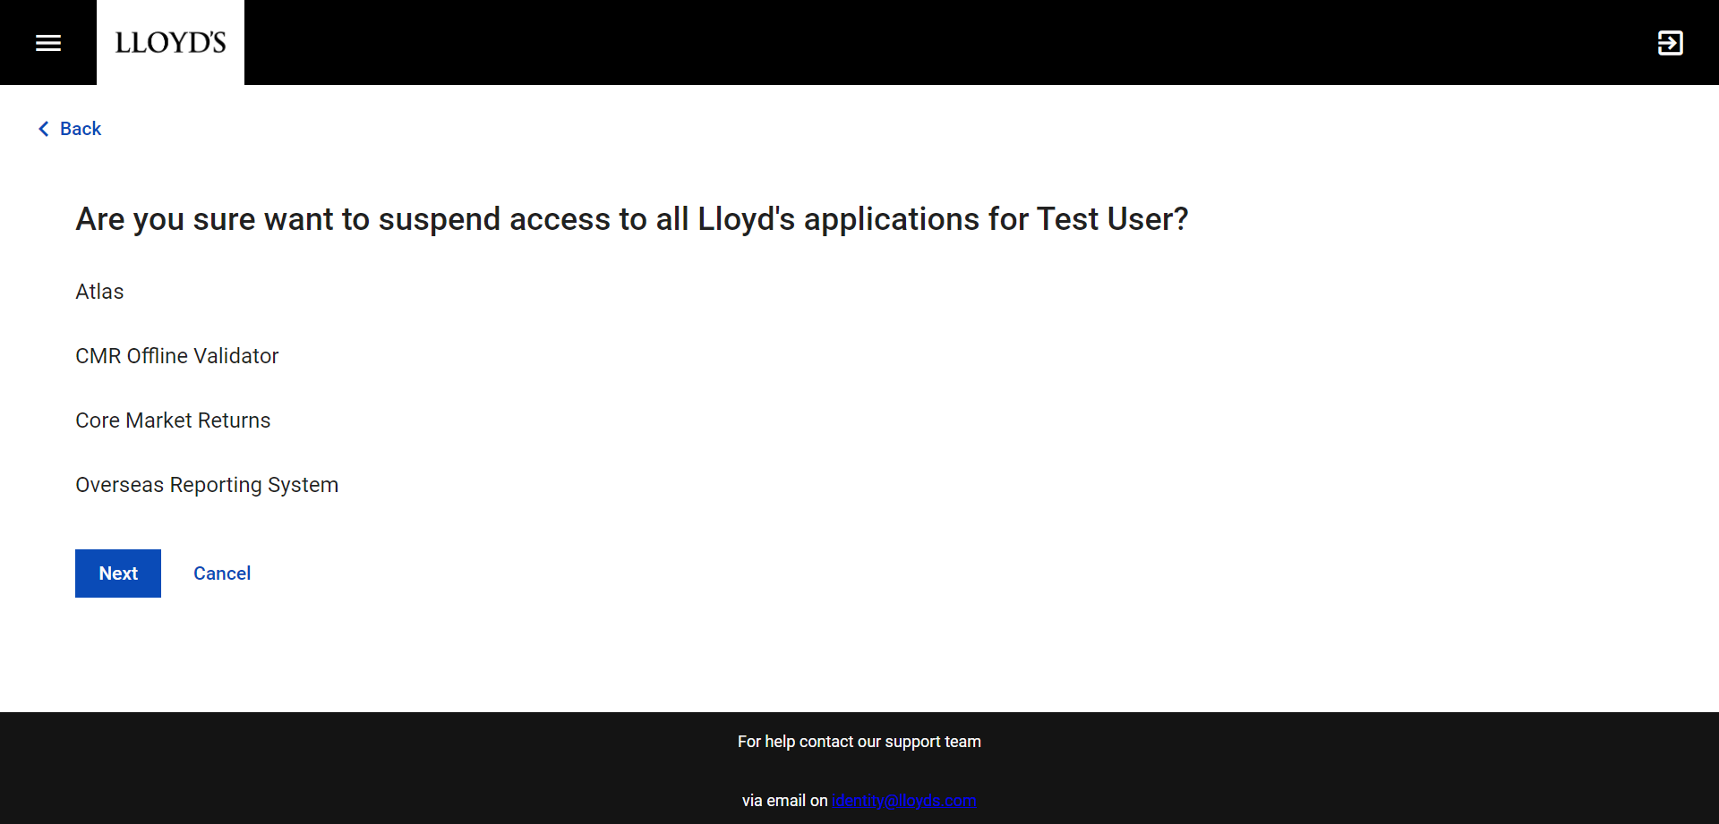
Clicking the ‘Next’ button on this screen will confirm your suspension and trigger and email notification.

To un-suspend your account you will need to contact an administrator or application owner.

Deleting your account
Deleting your account means that you will permanently lose your access to all applications.

Access your profile either by logging in to Identity@Lloyd’s or selecting ‘Profile’ from the menu if you are already logged in.

Click the ‘Delete my account’ button, this should display a confirmation screen asking you to confirm the deletion.
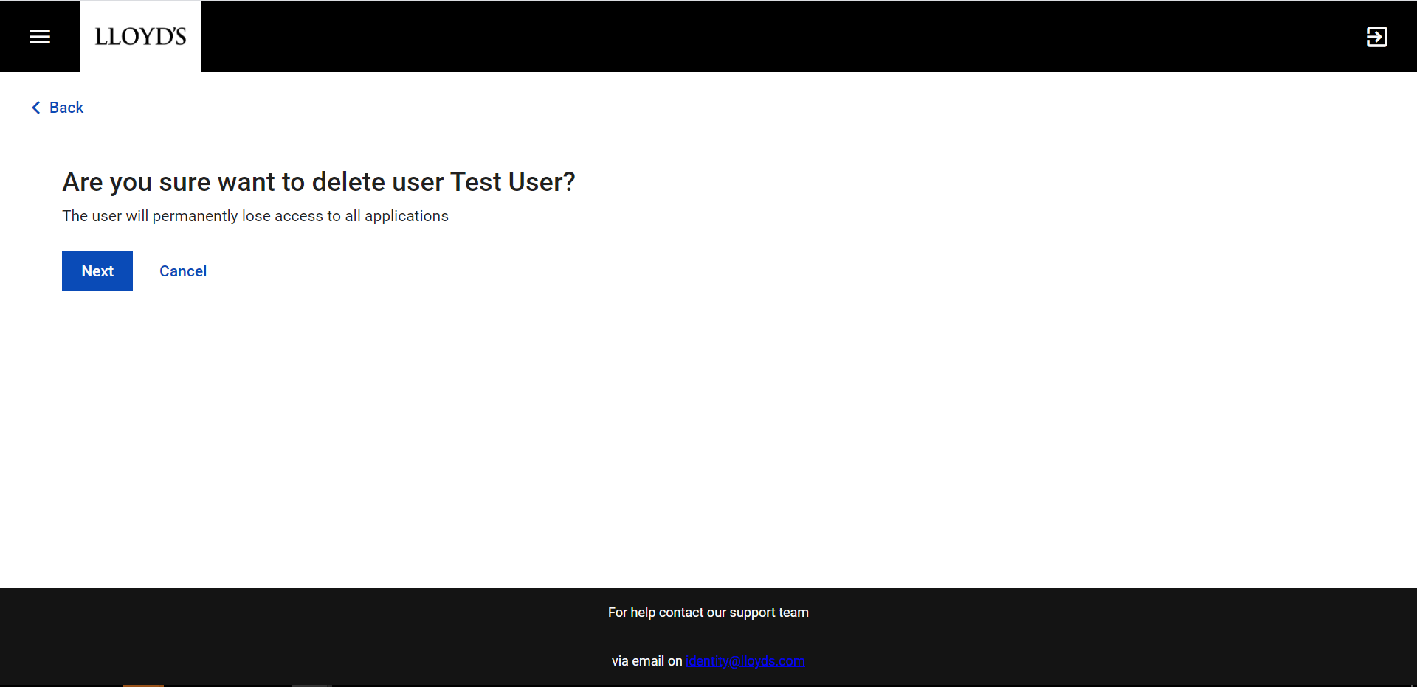
Clicking on the ‘Next’ button will confirm the deletion of your account. After this, your account will be suspended for 5 days before being permanently deleted.

User profile
Your profile page is displayed when you first log in. The profile shows your user details as entered when you first registered, the applications that you have access to and the actions available to you.

From this page you can edit your user details, view your access rights to applications, and complete other actions.

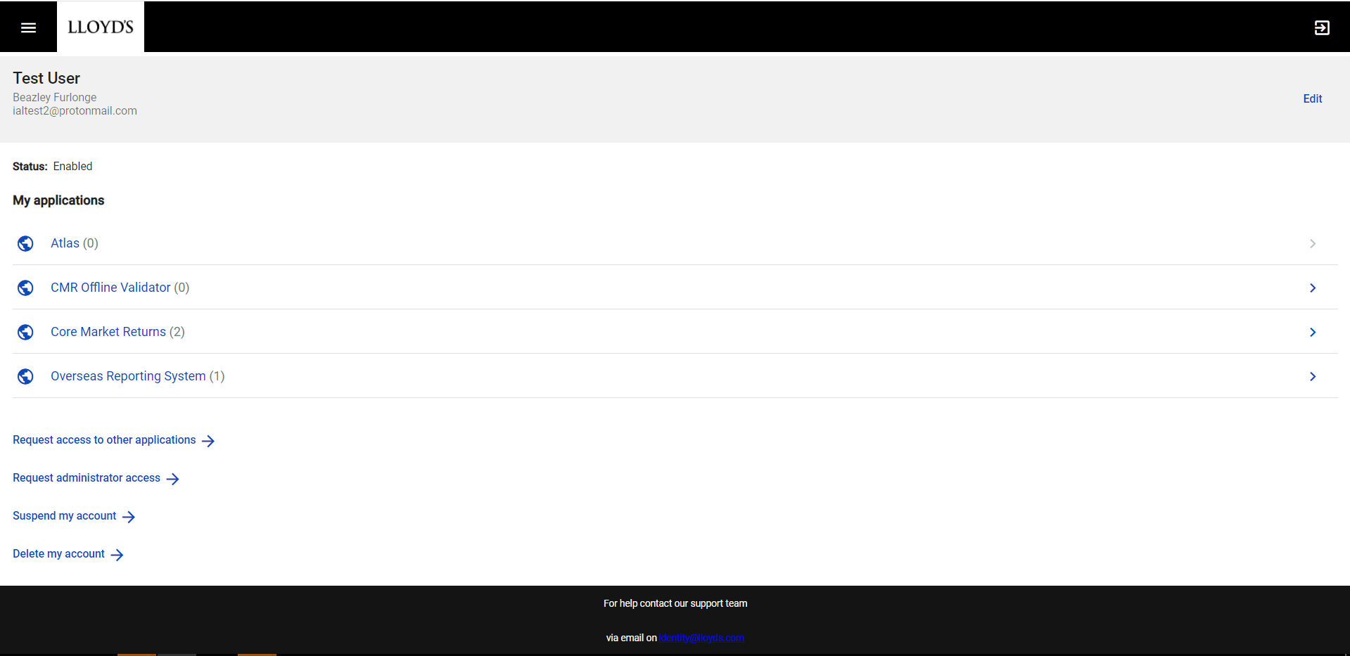

The number in brackets next to each application represent the level of access you have. A (0) means no access to an application (may have been removed) and (1) or more signifies access to the application at at least 1 level.

Passwords
You can reset your password by clicking on the link on the login screen

On the password reset screen enter the email address for your Identity@Lloyd’s account and click ‘Send email’. When you have received the email click on the link to set your password, after which you should be able to successfully log into your application(s).

For further support please email Identity@Lloyds.com and we will try and assist you.

