Identity@Lloyds

Contents:

Requesting Administrator access
Adding a new user
Adding multiple new users
Reviewing user requests
Reviewing user profiles
Requesting user access to other applications
Making a user an administrator
Suspending a user
Deleting a user

Note: Currently only access to Core Market Returns, CMR Offline Validator and the Overseas Reporting applications can be administered through Identity@Lloyd’s. Other applications will be available in due course.

Requesting administrator access

Access your profile either by logging in to Identity@Lloyd’s or selecting ‘Profile’ from the menu if you are already logged in.
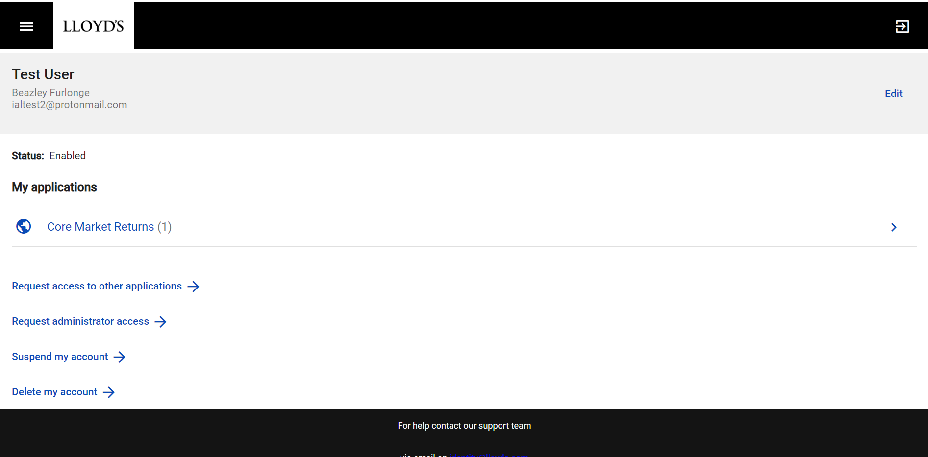

Click the ‘Request administrator access’ button, this should display a list of the applications you already have access to.
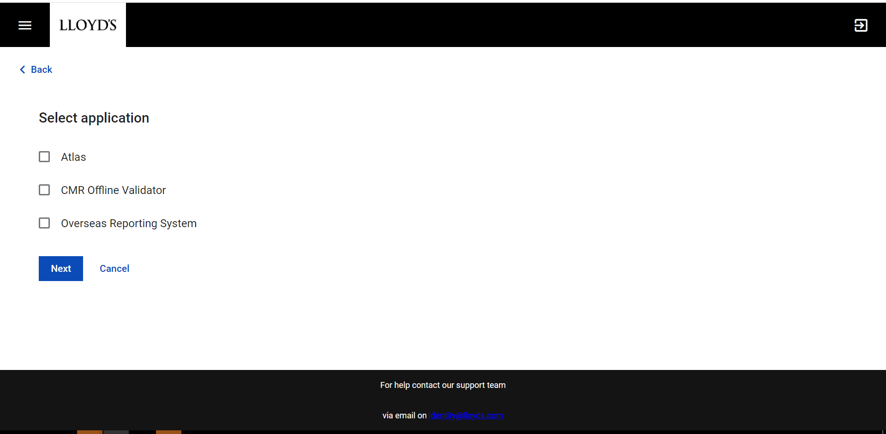
Select the application you want administrator access to by checking the appropriate box and click ‘Next’.

On the next screen, select the appropriate rights that you want admin rights for and click ‘Next’. You may have rights for more than one organisation depending on your job role.
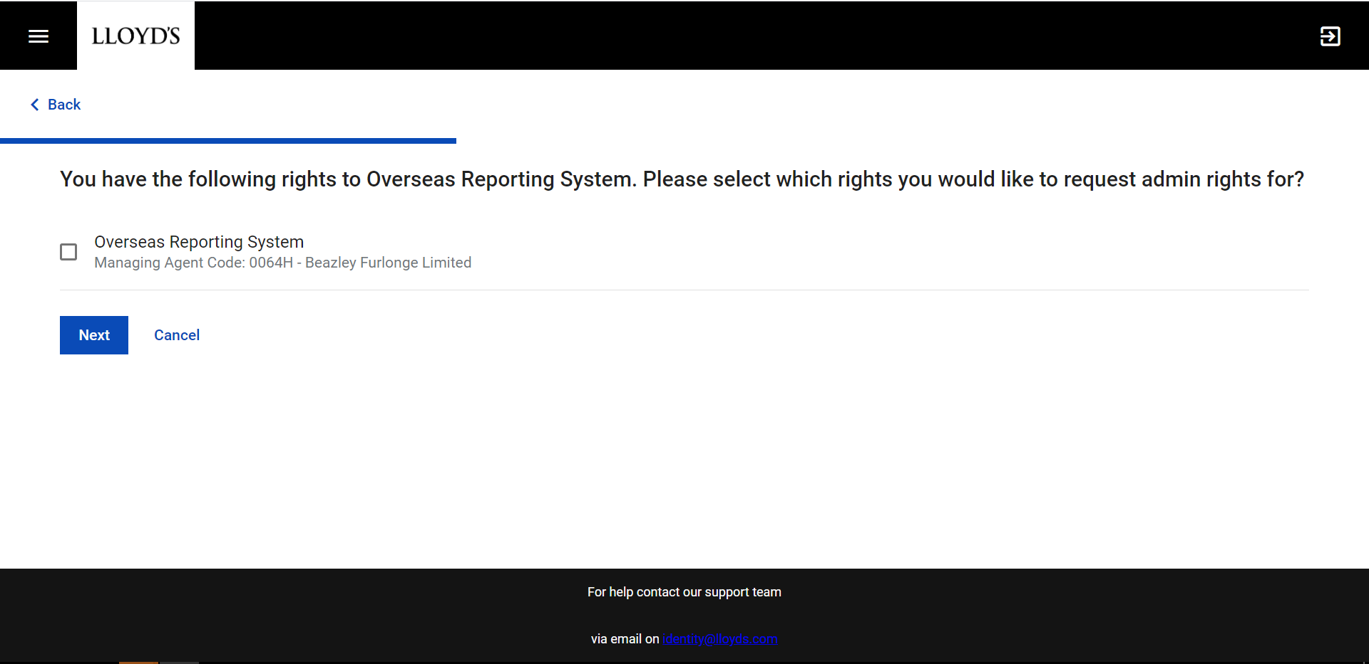
Confirm your request by clicking Next on the confirmation screen.
You will receive an email confirming your request and your request(s) will be sent to the appropriate administrator(s) for review. You will receive an email notifying you of the outcome once your request has been reviewed.

Adding a new user
From your profile page, access the ‘Admin’ screen from the menu. On the Admin page select the ‘users’ tab, then the ‘+’ symbol
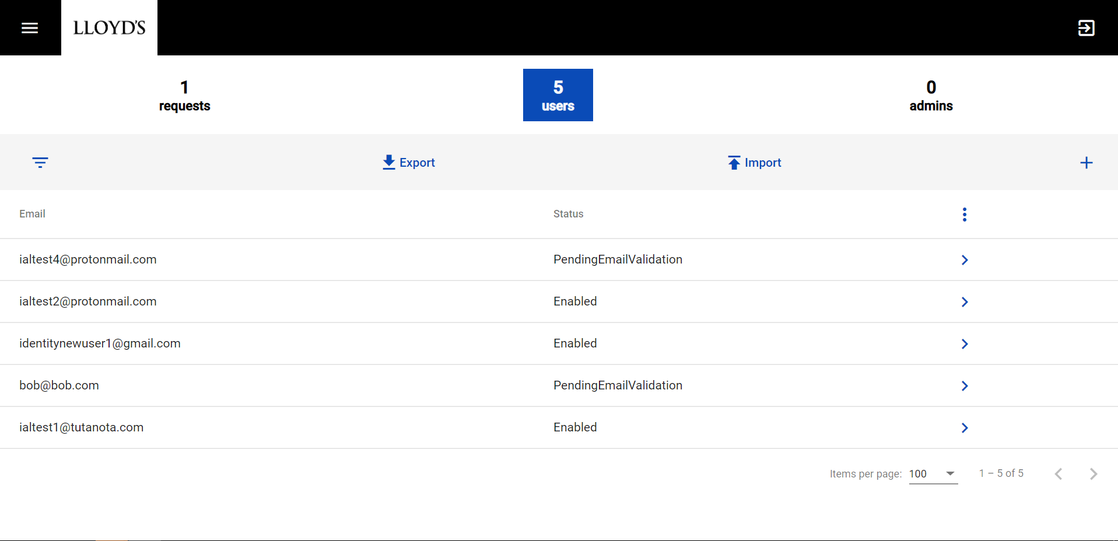
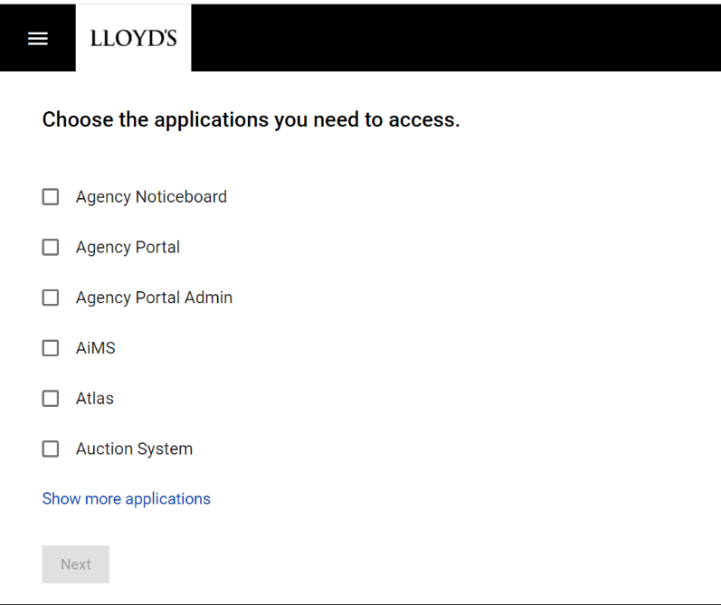
You should be presented with a screen showing a list of applications.

Select the application(s) that you would like the new user to access by clicking the checkbox by the application name. The list can be expanded by clicking ‘Show more applications’.

Click on the ‘Next’ button to progress with the user set up.

The next screen requires you to enter the user details. All fields on this screen are mandatory. A valid email address must be entered as user verification and password setting emails will be sent to this address.

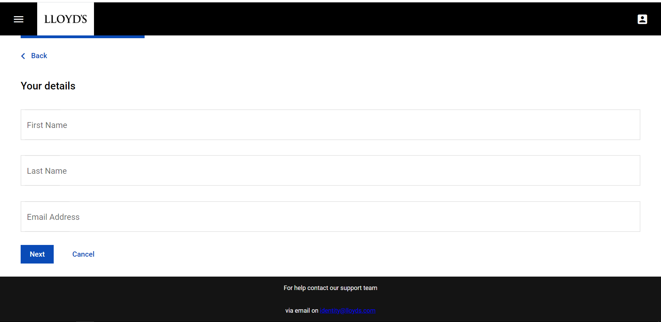

Once you have completed all the fields, click ‘Next’ to proceed with the request. The next screen captures details of the user’s organisation.

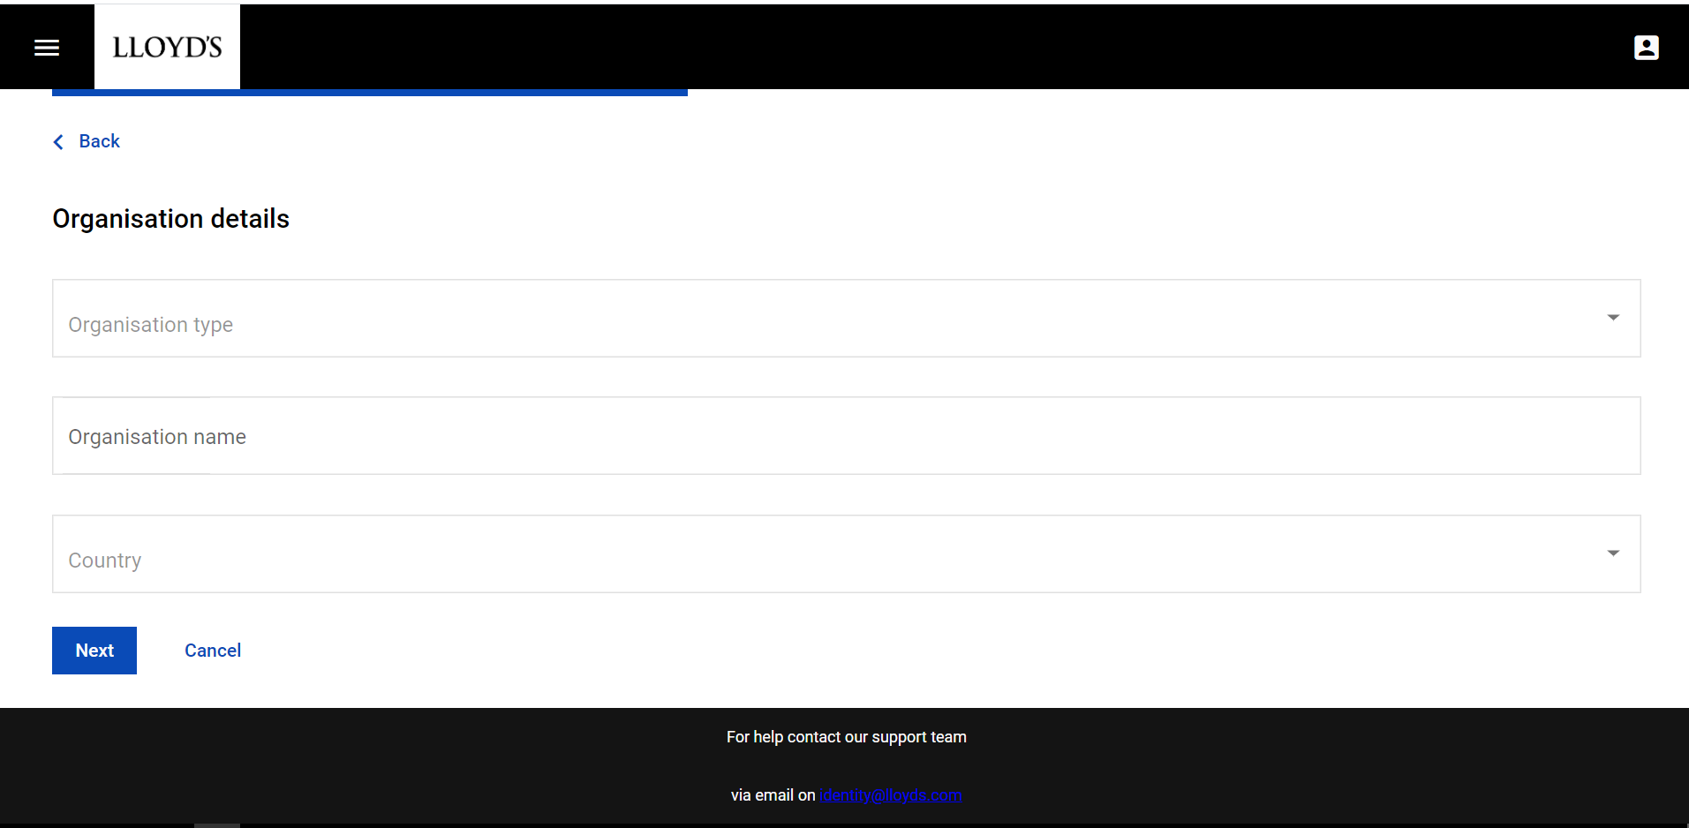

Select the ‘Organisation type’ from the drop-down list. Manually enter the ‘Organisation name’ and select the ‘Country’ location from the drop-down list. Once again, all the fields on this screen must be completed. Click ‘Next’ to proceed with the access request.

The next screen will display the additional information you will need to complete the request depending on the application(s) the user requires access to. If you are requesting access to multiple applications, each additional requirement will be listed on this screen.

Once you have gathered all the additional information for your request, click ‘Start’, Identity@Lloyd’s will then present the information screen appropriate to the application(s) you have requested access to.

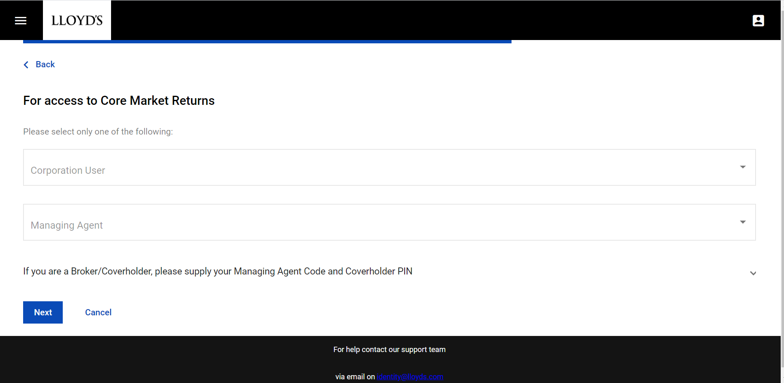
Once you have completed the required information, click ‘Next’ to progress to the next screen. If you have requested access to more than one system, this screen will be repeated until all the information required by each application has been provided.

After the final information screen has been completed, Identity@Lloyd’s will show a screen summarising your request. Check all the information you have entered is correct and click on the ‘Send Request’ button.
The user will be automatically set up with the access you have requested for them, without the need to approve the request.

The user will receive several emails as follows:
- A request verification email – this must be actioned within 24-hours
- A password reset email
- Emails confirming each application request you made

Adding multiple new users
When users are uploaded to Identity@Lloyd’s in bulk, they will all be created with the user access rights for the same organisation as the loading administrator.
From your profile page, access the ‘Admin’ screen from the menu. On the Admin page download the template and save it to a memorable place on your computer.
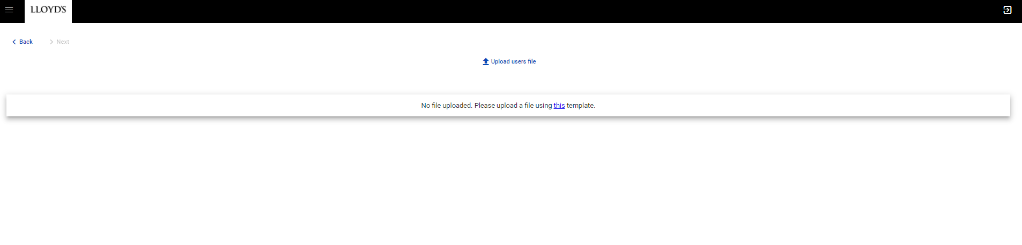

The blank template looks like this:
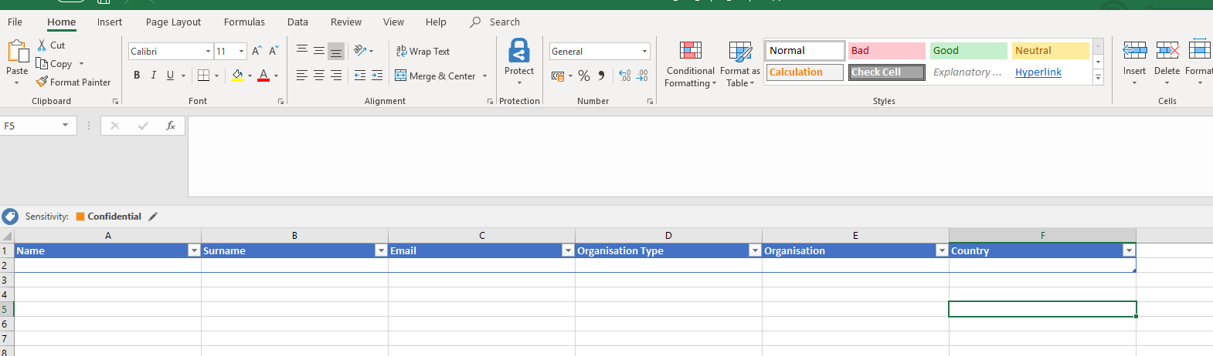

Populate the required template with up to 50 users and save it to your chosen location, then click on the ‘Upload users file’ button. The uploaded file is run through some formatting checks and any issues are highlighted in the screen.

Errors must be corrected in the file to complete the upload. You can make amendments to your file and re upload until everything is in the correct format.
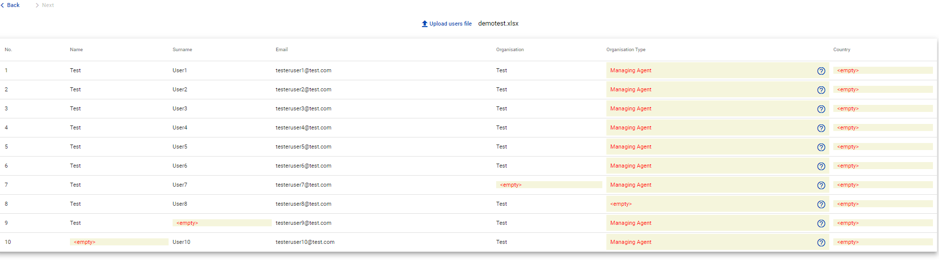
All fields must be completed and a full list of valid values for the ‘Organisation Type’ is available by clicking on the ‘?’ symbol.

Once the upload file is correct, click the ‘Next’ button to select the rights to give to the users.

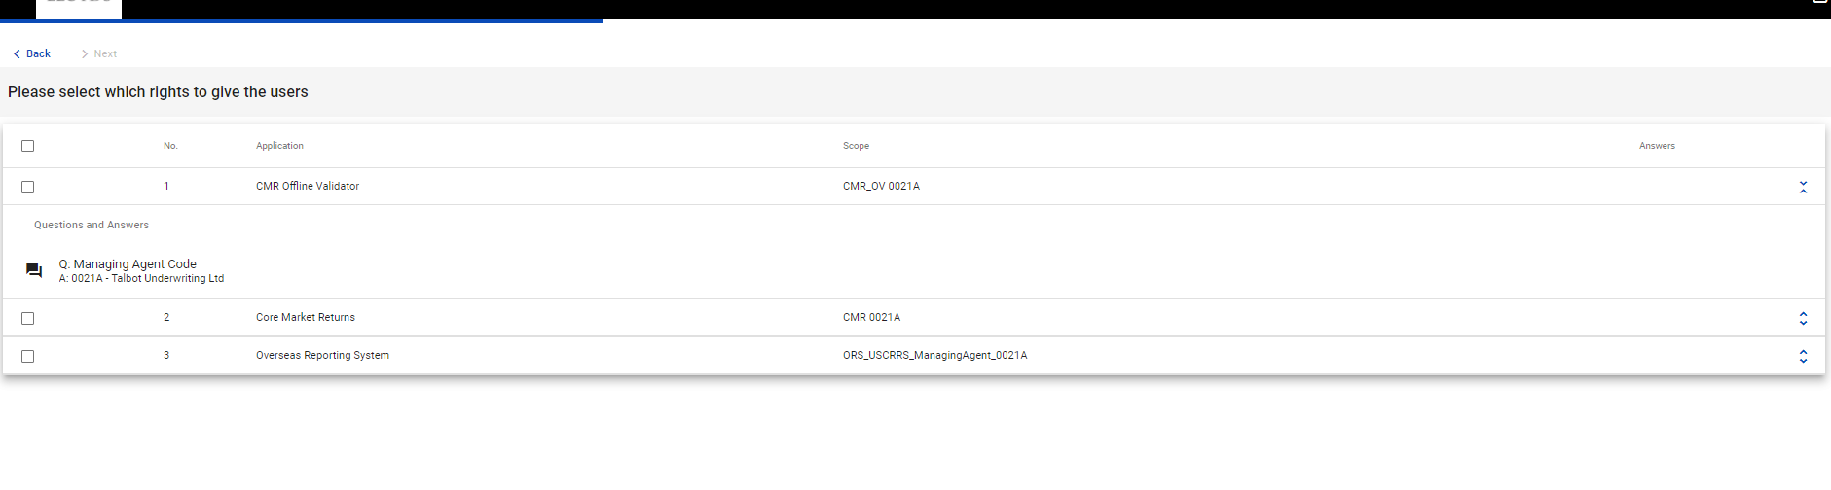
Note that you can upload the users for all the applications you have access to, the access details can be checked using the arrows on the right hand side of the record, and one or more applications can be selected – the choice is up to the administrator.

In this example we select 2 applications, using the tick boxes on the left hand side of the record.
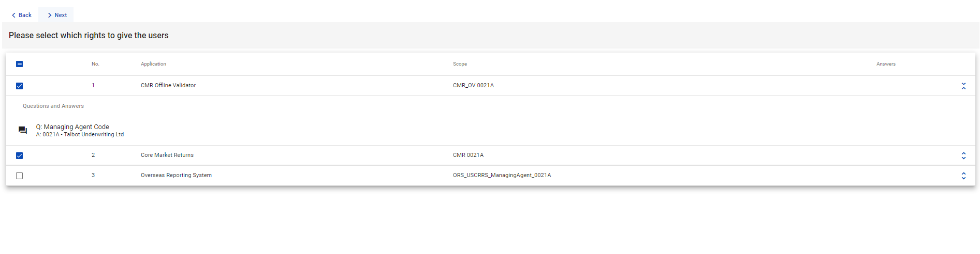
Select ‘Next’ and review the details before submitting. This screen confirms the number of users being uploaded and the number of access rights being granted. Note that you cannot create administrators via this process, this is merely to bulk upload users.
Once ‘Submit’ has been clicked, the user creation process will start. Users will be emailed to complete the registration process as if they were registering themselves (if new users) and you will receive an email confirming the users have been set up.

Reviewing user requests
As an administrator you are responsible for reviewing and actioning user access request for the Lloyd’s applications you administer for your organisation.

You will receive an email notifying you of each new request and a daily email reminder of any outstanding requests to be reviewed.

When you open the Admin screen from the menu, the default view is ‘requests’. From this screen you can quickly approve or reject user requests.

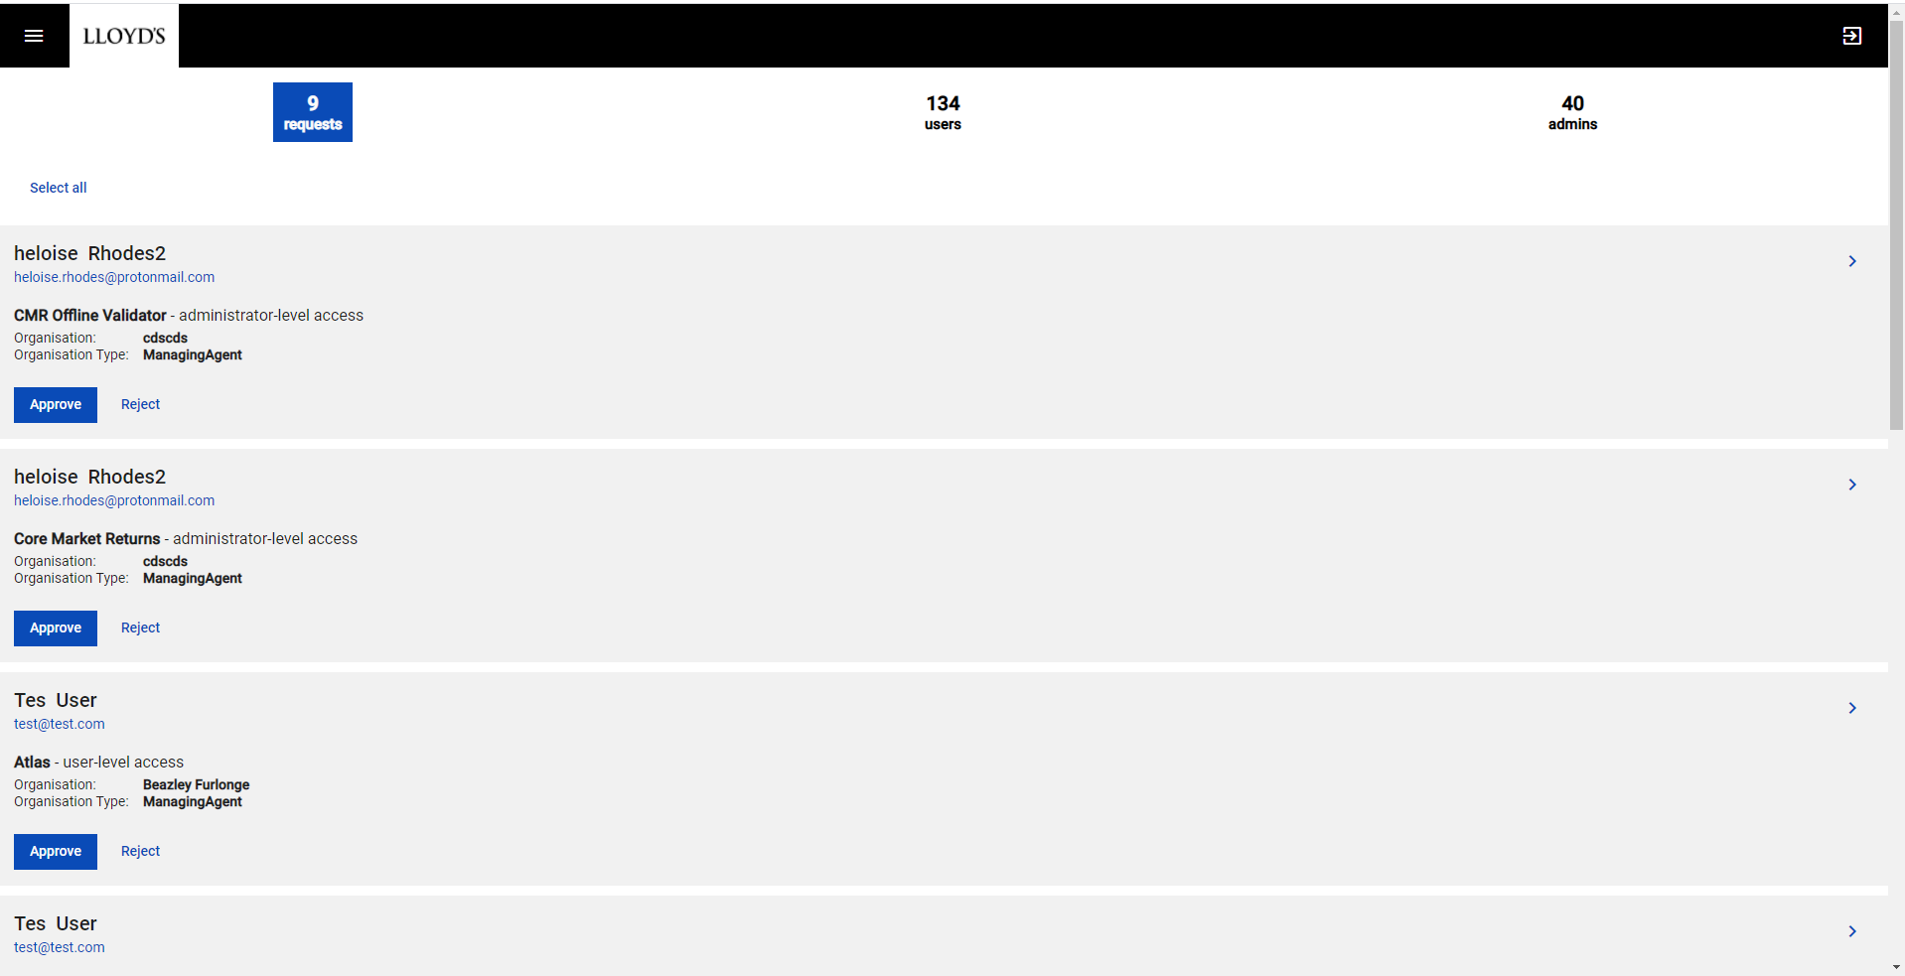

You can also expand individual requests by clicking on the ‘>’ symbol at the right-hand side of each request. This provides a more detailed view of the request and the option to ‘Approve’ or ‘Reject’.

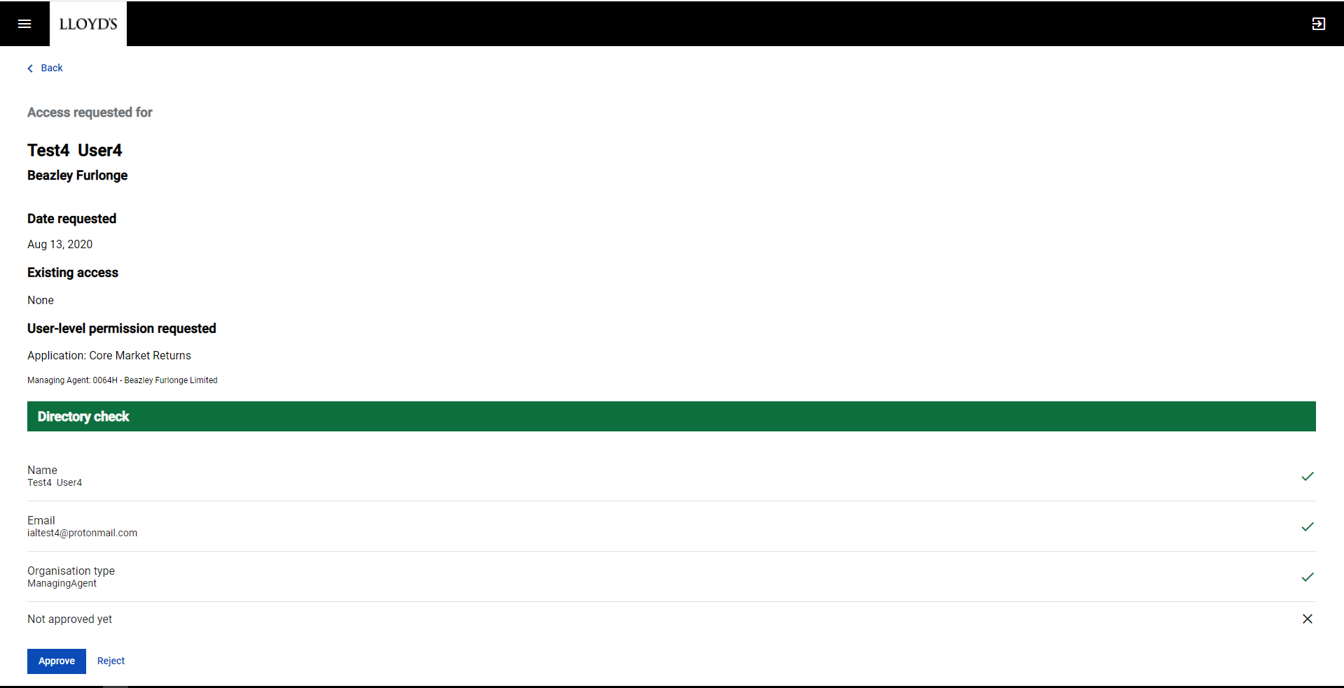

Once you click the ‘Approve’ button, the user’s access rights will change, and an email will be sent to the user confirming their new access.

If you decide to reject a request, you will be prompted to enter a reason, which will be included in an email sent to the requesting user.

Reviewing user profiles
As an administrator you are responsible for managing the users of the Lloyd’s applications you administer for your organisation.

When you open the Admin screen from the menu select the ‘users’ tab. This view shows all the users in your organisation who have access to the Lloyd’s applications that you administer.

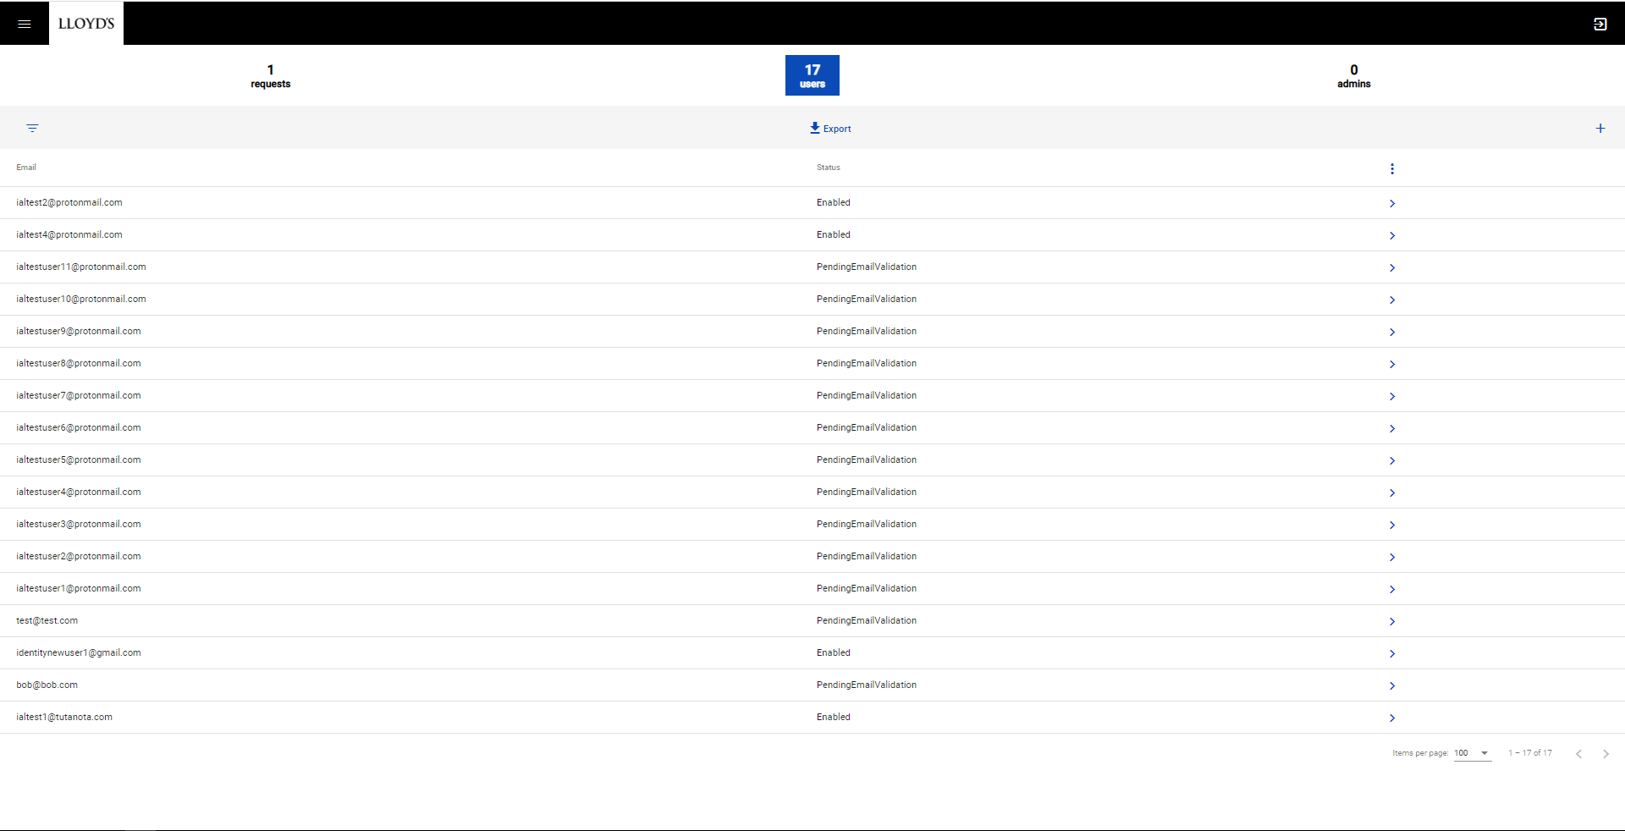

Access the user you want to review by clicking on the ‘>’ symbol at the right-hand side of each user record.

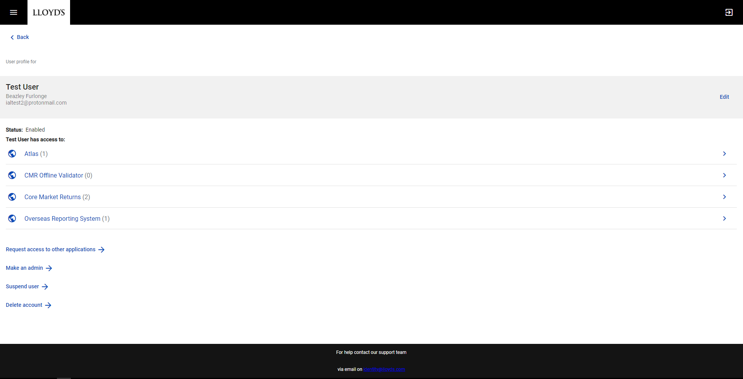

From this page you can edit the user details, view the user’s access rights to applications, and complete other actions.

Requesting user access to other applications
You can request access to other applications on behalf of a user under your administration by clicking the ‘Request access to other applications’ button on their user profile.

Once you have clicked the button you will follow the screens for adding a new user previously referenced above.

Making a user an administrator
You can make a user under your administration an administrator by clicking the ‘Make an admin’ button on their user profile.

Once you have clicked the button you will follow the screens for requesting administrator access previously referenced above.

Suspending a user
Suspending a user means that they will not have access to their applications for period of time, which may cover extended leave from work, secondments or other instances when access isn’t needed but will be needed again in the future.

You can suspend a user under your administration by clicking the ‘Suspend user’ button on their user profile The following confirmation screen should then be displayed.

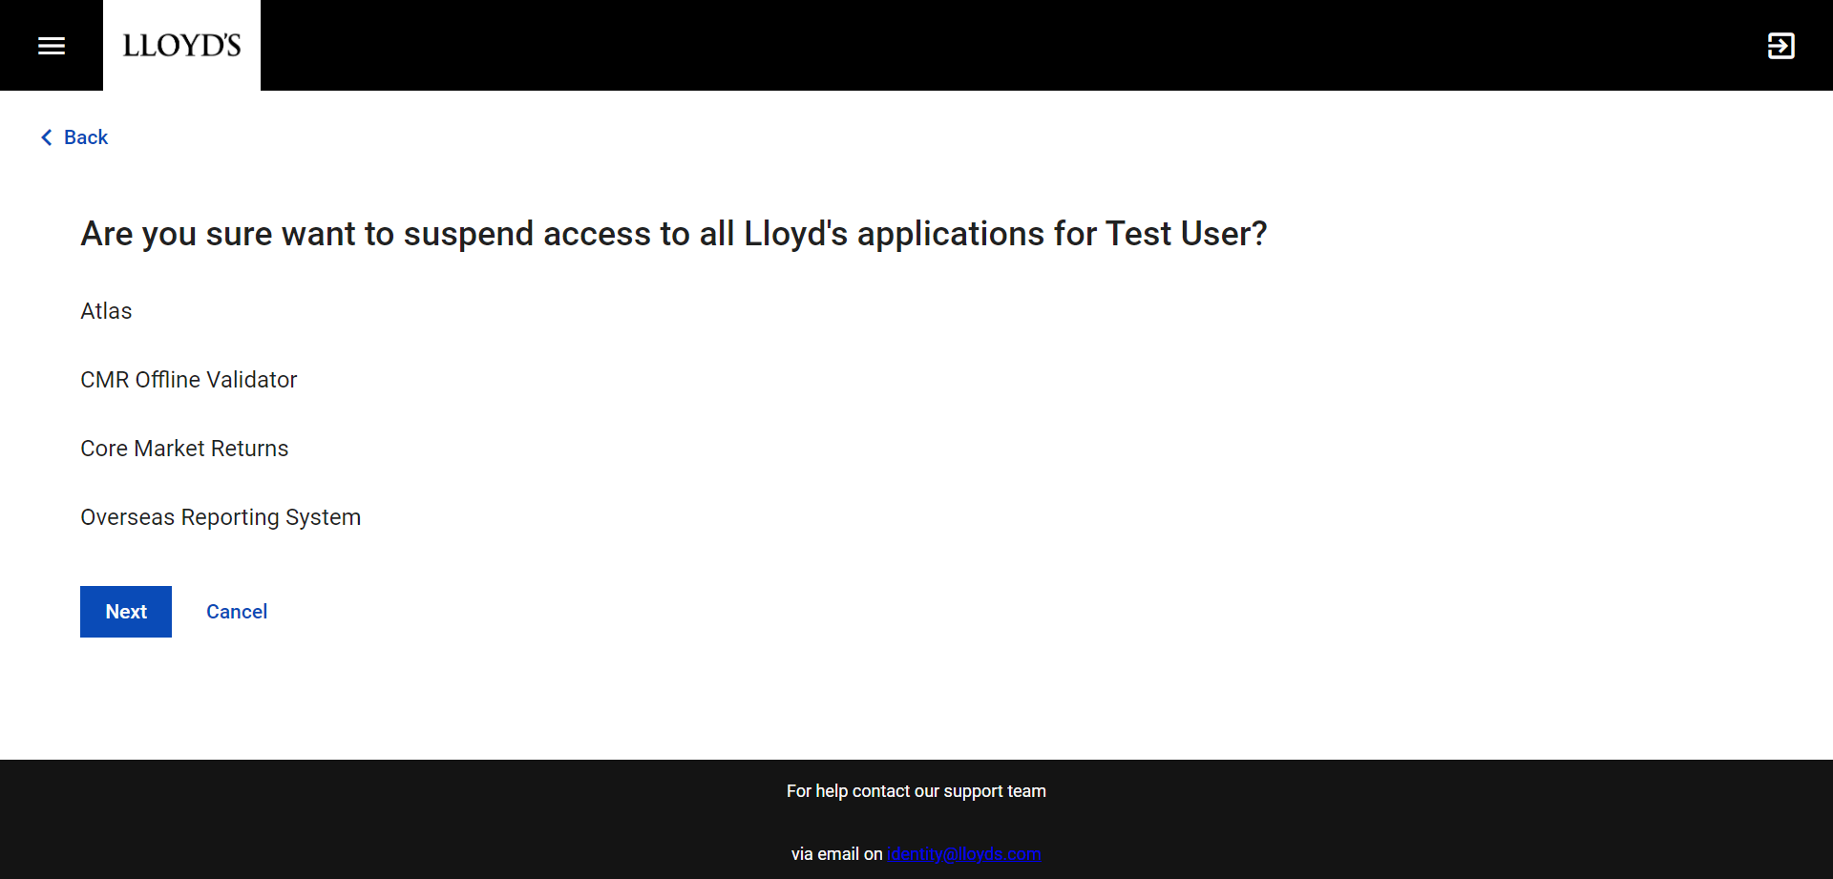
Clicking the ‘Next’ button on this screen will confirm the suspension and trigger an email notification to the user.

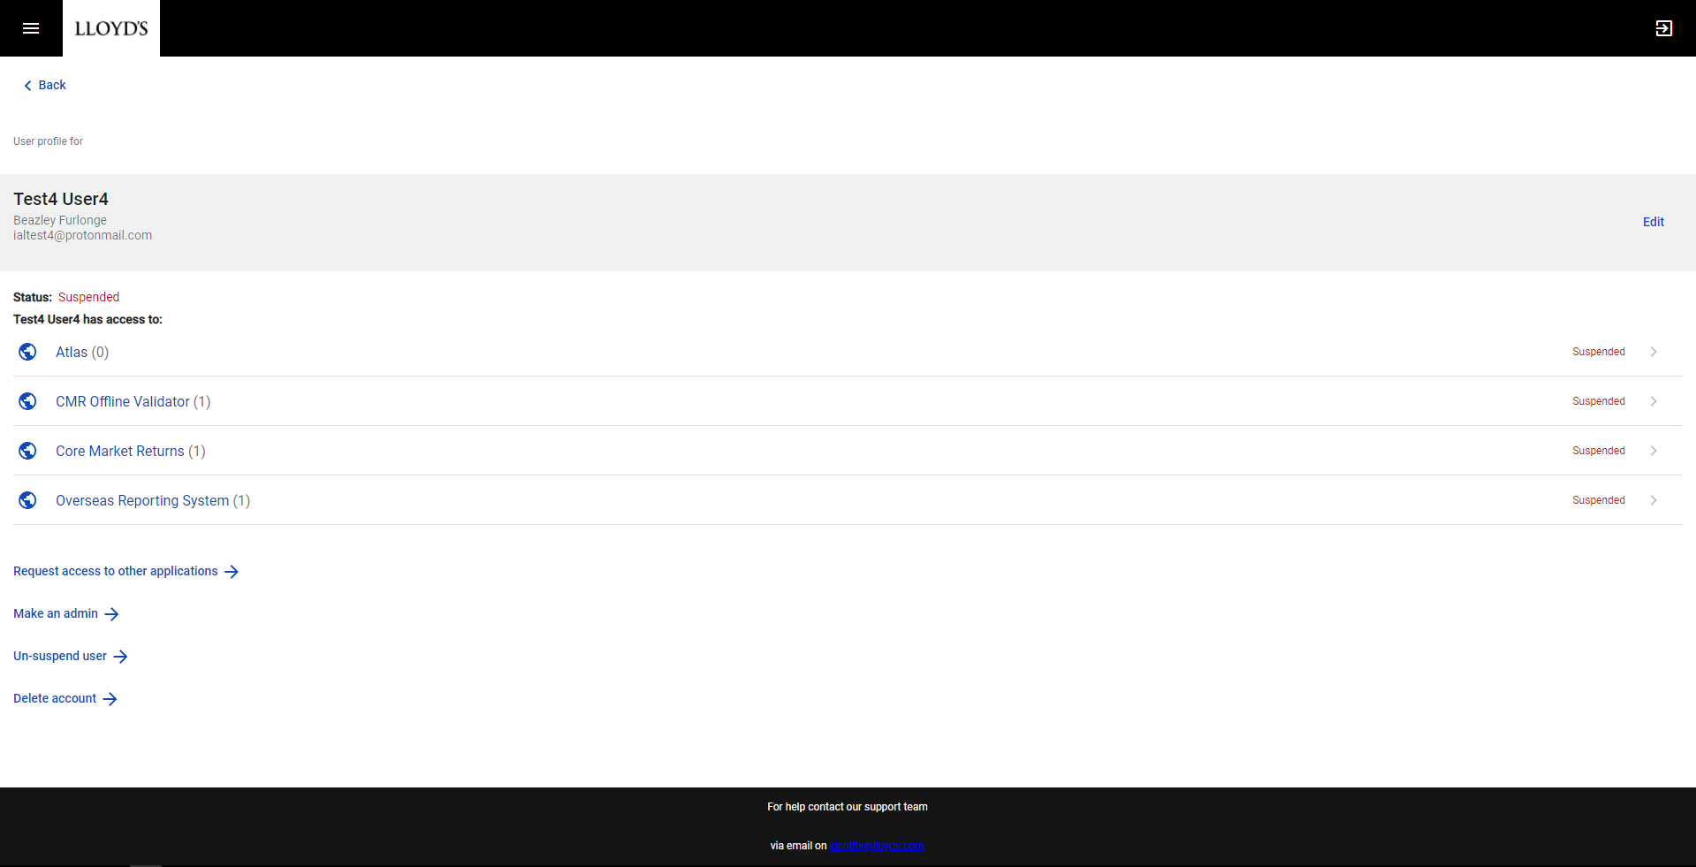

The user’s profile will be updated to show they are suspended. To unsuspend the user, click on the ‘Un-suspend user’ button and confirm the unsuspension on the next screen. This will trigger another email notifying the user that their access has been restored.

Deleting a user
Deleting a user means that they will permanently lose access to all applications.
You can delete a user under your administration by clicking the ‘Delete user’ button on their user profile, this should display a confirmation screen asking you to confirm the deletion.

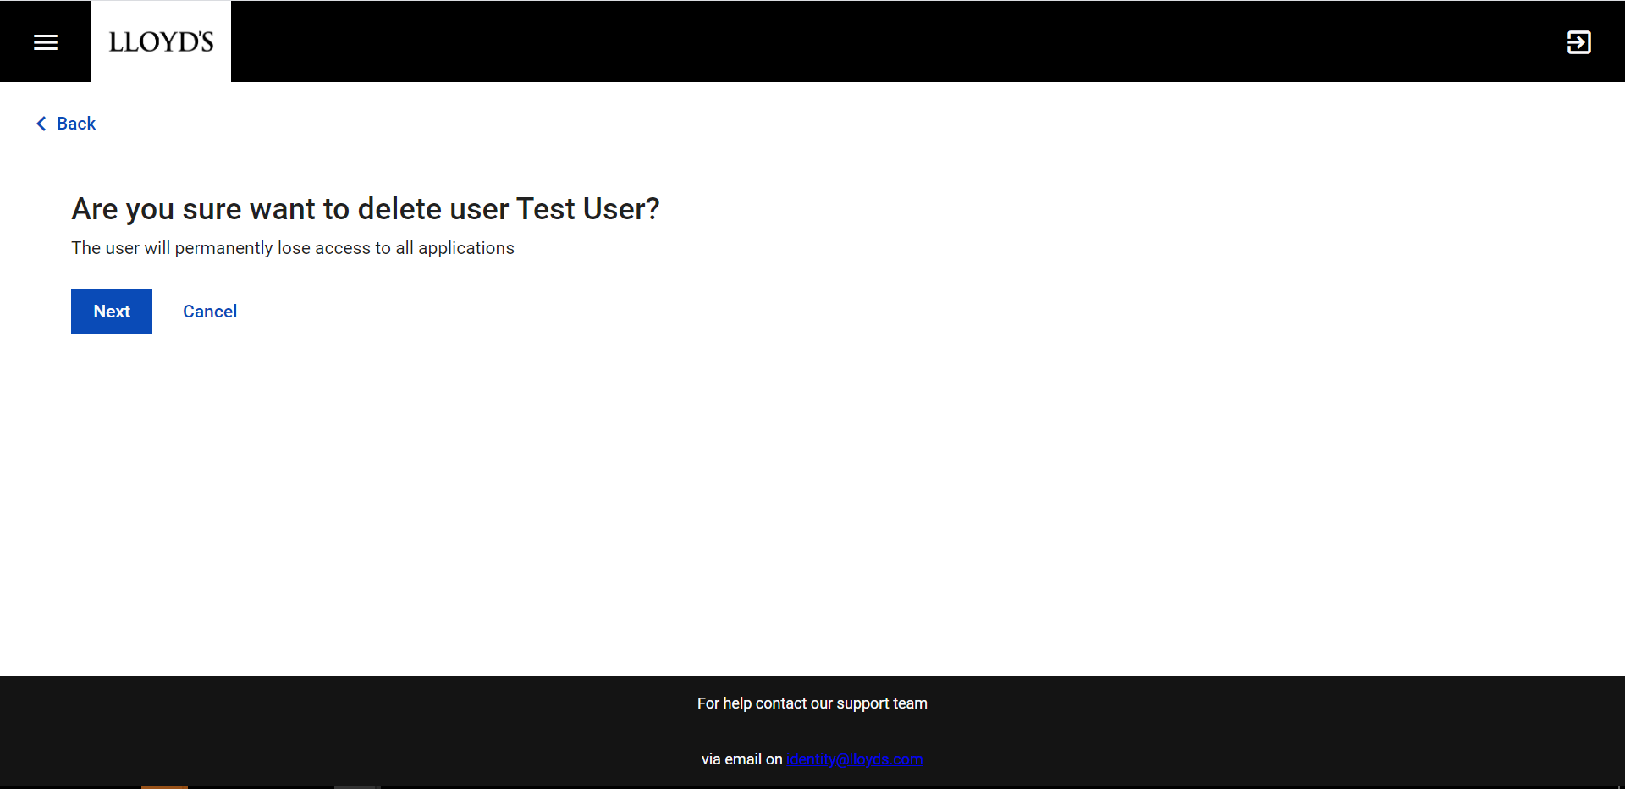

Clicking the ‘Next’ button will confirm the deletion of the account and trigger an email notification notifying the user that their access has been removed. The account will be suspended for 5 days before being permanently deleted.

For further support please email Identity@Lloyds.com and we will try and assist you.

