LAF and Identity@Lloyds administrator guide

Contents:

User registration
Basic user management
Other information – known issues and resolutions

User registration

Note: this excludes Core Market Returns (CMR), CMR Offline Validator and Overseas Reporting System (ORS)
When users register for applications which require administration in LAF, they must register, verify their account and set the password before their account is active. This password is only valid for LAF.
Please be aware that until the user has access to an application their account will not be synchronised with the identity@lloyds system until they have access to one application. Therefore you will need to add the user to the appropriate user groups in LAF before users can successfully log in.
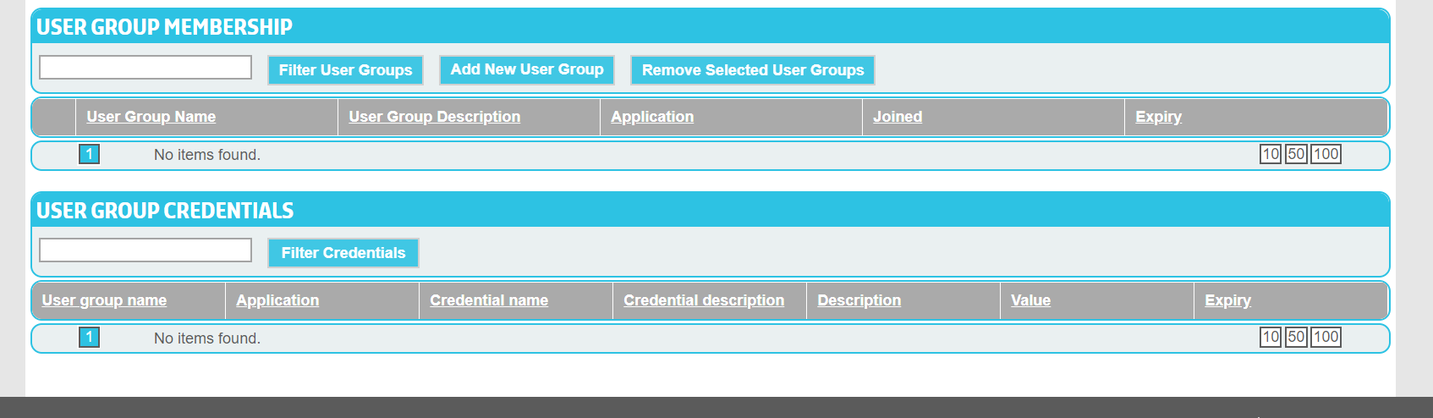
This user will not be able to access any applications and will not by synchronised.
A user which will successfully synchronise will look similar to the below:
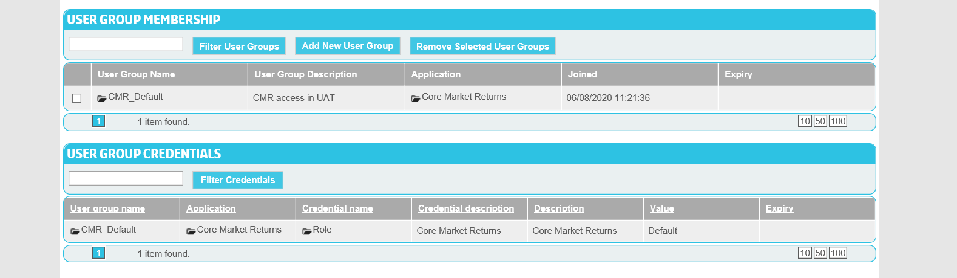
Once the access has been granted then their account will synchronise. This will take up to about half an hour.
After this process is complete, the user can log into their application(s). The first time the user logs in they will need to set a password to access the applications. Note: LAF and identity@Lloyd’s are separate systems and maintain their own passwords; these are not synchronised.
Once this process is complete the users should then be able to access the application.

Basic user management

Basic user management for most applications does not currently change.

Users can be searched for using the search function presented on login which should look similar to this:

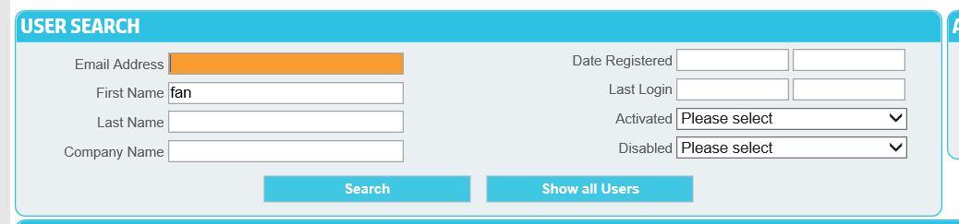

Once users have been found their account details should appear in the screen below and the user record can be opened by clicking on the folder next to their name.

Then you will be able to add user groups to the user as per normal.

When a user requires access to additional user groups, please add them to the user as per normal, noting that the additional access will need to synchronise and may take up to half an hour to complete. Once this process is complete the user should be able to access the newly added application

When user group membership is removed from a user, again it will take up to about half an hour before the user is prevented from logging in. Please be aware of this when removing access.

Other information – known issues and resolutions

Passwords

LAF and identity@lloyds are different systems and maintain different passwords. Therefore when you are administering (adding / removing users from user groups) users, your LAF password is different to that used when logging onto Lloyd’s applications.

To avoid confusion:

LAF password screen:

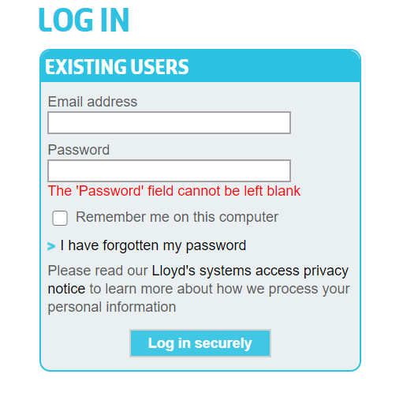

Identity@lloyds password screen:

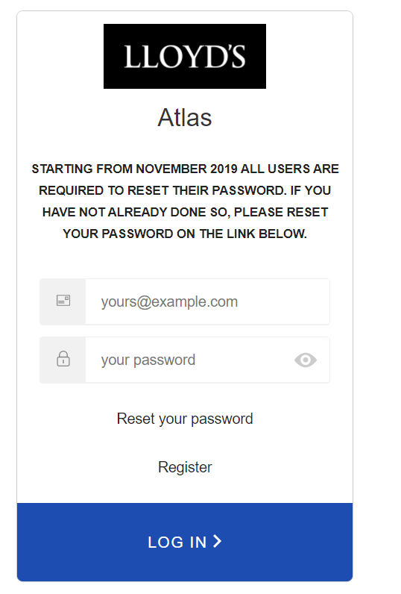

Synchronisation

The synchronisation process runs every fifteen minutes and therefore may take up to half an hour to complete. The synchronisation process takes the user groups and makes them available to the identity@lloyds system. A new user will not be synchronised if they do not have user groups associated to them.

There is also another scenario where users may not be synchronised and this affects users who have not logged in for 18 months or more. Details on how to resolve this scenario can be found in the user guide.

Login messages

There is a default error message which is presented when a user provides an incorrect username or password is entered. The same message appears when a user has not yet been synchronised. This will be changed, however for the interim period, please verify that a user actually registered AND been given to appropriate user groups before contacting the helpdesk.

LAF and identity@lloyds relationship

The LAF and identity@lloyds dependency is a temporary one. There are some outstanding activities to be planned to migrate the existing LAF applications into identity@lloyds. These activities will be communicated separately.

