LAF and Identity@Lloyds user guide

Contents:

How to register as a new user
Requesting additional access as an existing user
If you have not logged in for more than 18 months

How to register as a new user
For the following applications you will need to refer to the Identity@lloyds user guide:
- Core Market Returns (CMR)
- CMR Offline Validator
- Overseas Reporting System (ORS)
For other market facing applications for registration please follow the following steps:
Go to Lloyds.com and select Login/register from the menu. In the login screen that appears select Register:

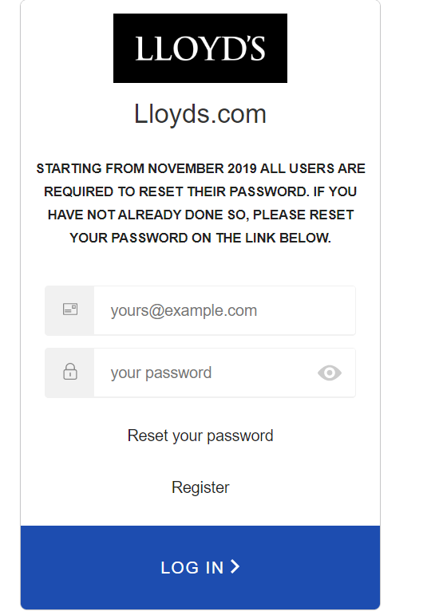

You should be presented with a screen called ‘Create a Lloyd’s account’. (screenshot) Enter the details requested, read and accept the terms and conditions and select ‘Submit’.
Once submitted, you will receive an email to activate your new Lloyds account. Click on the link within this email within 4 hours of submission to activate your account. Once clicked you will receive a confirmation message that your account is active.

After you have successfully completed the registration process, you will need to talk to your administrator or the appropriate Lloyds team via the ‘my account’ page on Lloyds.com or https://www.lloyds.com/tools-and-systems/secure-applications .

After your administrator confirms your access has been granted, you will need to wait between 15 to 30 minutes before logging in. This is due to the timing of synchronisation processes. Before you log in for the first time you will need to set a password for access to your application(s). Please be aware that LAF and identity@lloyds are separate systems and therefore maintain separate passwords. You will not be able to access applications until this password is set.

You can set your password using the ‘Reset your password’ link in the login screen:

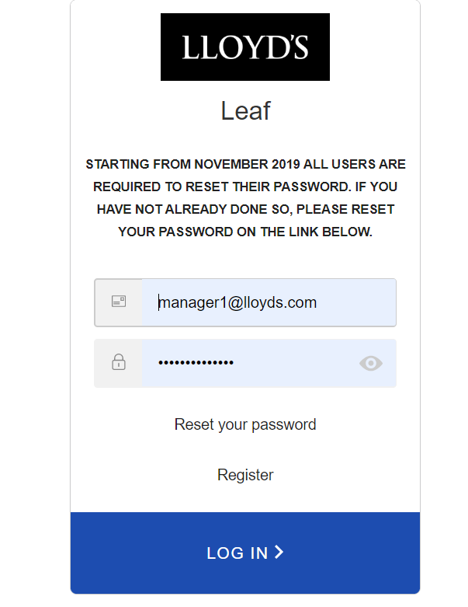

On the password reset screen enter the email address of your account and click ‘Send email’. When you have received the email click on the link to set your password, after which you should be able to successfully log into your application(s).

Requesting access to an application

If you need access to additional applications other than those you already have you will need to talk to your administrator or the appropriate Lloyds team via the ‘my account’ page on Lloyds.com or https://www.lloyds.com/tools-and-systems/secure-applications .

After your administrator confirms your access has been granted, you will need to wait up to 2 hours before logging in to the new application(s). This is due to the timing of synchronisation processes.

If you have not logged in for more than 18 months

If you have not logged in for 18 months or more, then your account will not have been synchronised with identity@lloyds. You will need to reset your password in LAF via the following link: https://secure.lloyds.com

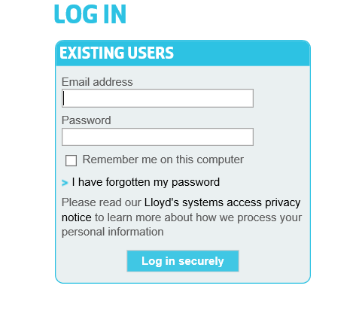
Click on the ‘I have forgotten my password link’ and then enter your email address. Once the request is submitted you will receive an email which contains a link. Click on this and you should be able to reset your password. Once this has been reset and you log into https://secure.lloyds.com, your account will start the synchronisation process which will take between 15 to 30 minutes.

Before you log in you will need to set a password for access to your application(s). Please be aware that LAF and identity@lloyds are separate systems and therefore maintain separate passwords. You will not be able to access applications until this password is set.

You can set your password using the ‘Reset your password’ link in the login screen:

On the password reset screen enter the email address of your account and click ‘Send email’. When you have received the email click on the link to set your password, after which you should be able to successfully log into your application(s).

Other information
If you cannot log in, please do not keep trying to log in with the same username and password. This may result in your account being blocked which you will not be made aware of. If you cannot log in please contact the service desk.

The LAF and identity@lloyds dependency is a temporary one. There are some outstanding activities to be planned to migrate the existing LAF applications into identity@lloyds. These activities will be communicated separately.

