Victoria Louise Carter
Working Member
Statement
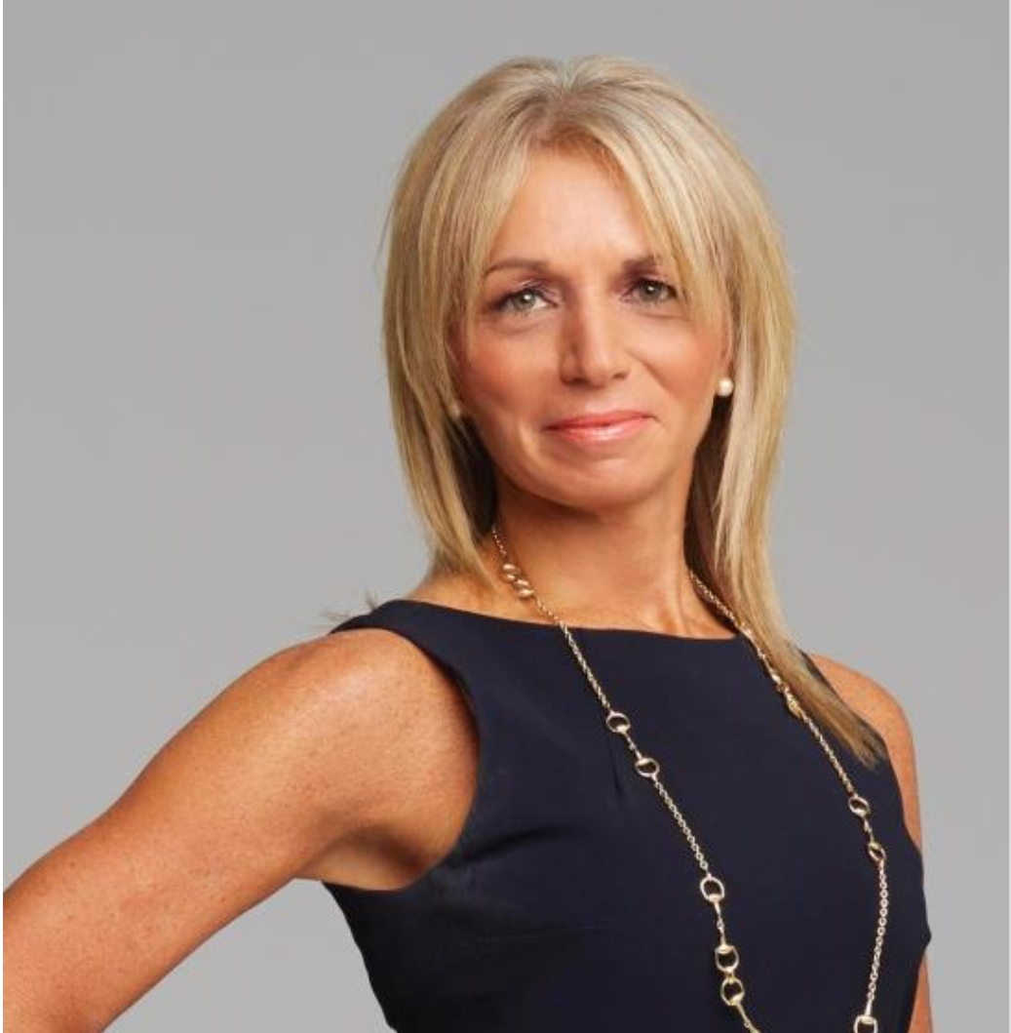
I have had the enormous pleasure of working as a Lloyd’s broker for the last 38 years, my entire career in the industry. During this time, I have witnessed the continual adaptation of the industry to the ever-evolving world and the emergence of alternative risks.
Lloyd’s, despite facing continued challenges, has remained the pre-eminent centre of excellence and marketplace for specialty risk, both insurance and reinsurance, and continues to attract capital, business and talent from around the globe.
Critical to its success has been its ability to re-emerge following R&R to a position of strength by virtue of the Performance Management Directorate, the ever-increasing presence of diversified corporate capital, its rating and global licensing.
The market currently faces more pressing issues: geopolitical instability, financial and economic instability, new and emerging risk and ever-increasing disruptive influences. Therefore, it is imperative more than ever that we continue to support the market through innovation, adaption to advanced technology, digitisation and automation and embrace change rapidly. The ability to quote, bind and process in the most cost efficient manner, to ensure offering both full transparency and continued discipline, will be critical to its continued success.
I would like to think, as the first female founder of a Lloyd’s Broking House in 1992, that I have been an advocate of encouraging D&I and especially ensuring we continue to attract the best talent to our industry. For example through initiatives like the Young Professionals that I created at MMC and which has market-wide support. I have been fortunate to have held a number of Executive positions during my career and now have the privilege of being a member of the Executive Committee at Guy Carpenter. In my role, I have been instrumental in educating and securing third party capital to Lloyd’s from across all continents and a diversified business mix through these strategic relationships. Third party capital remains an important constituent of Lloyd’s capital and encourages a diverse and accretive business mix to the market. It is important that Lloyd’s remains attractive to all forms of capital, whether the traditional Names capital or alternative forms of capital, such as ILS.I continue to be fully involved in all aspects of reinsurance placement, third party capital, RI optimisations and the development of InsurTech initiatives within our industry.
Having been fortunate to have enjoyed the most incredible38 years in the industry, I feel we now have an obligation to preserve, protect and evolve the Lloyd’s franchise for the next generation, through continued education, adaptation to the emergence of new risk, state of the art analytics and technology that will enable it to compete successfully in the global market and to ensure Lloyd’s remains both competitive and relevant.
I very much hope through election to Council I can play my part in ensuring its future success.

