Flectat Limited
(Represented by Michael Watson)
Elected C-External Member
Statement
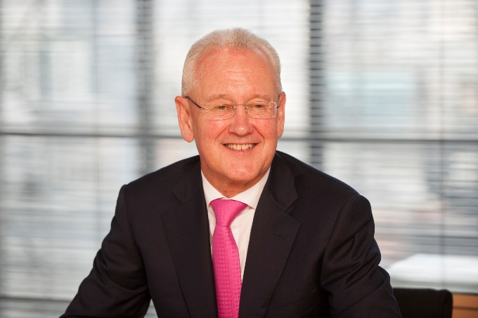
My financial services career spans 38 years in commercial and investment banking, stock broking, trade finance, and life and general insurance in the US, Canada, Latin America, UK, Europe, South East Asia, Japan and Australia.
My roles have included financial, strategic and general management based in London, New York, Bermuda and Dublin.
I have held Chairman and CEO roles with both private and public companies.
My Lloyd’s experience began in 1999 as NED of Kingsmead Managing Agency.
I subsequently led the MBO of Canopius in 2003, oversaw the sale to Sompo in 2014 and led the repurchase in 2018.
I currently serve as Chairman & CEO of Canopius Group.
As a member of Council, my areas of focus would include:
Purpose of Lloyd’s: In a rapidly changing world of insurance needs, technology and distribution, the structure and purpose of Lloyd’s needs to be reconsidered. Lloyd’s must remain a “must see” market, recognised for innovation and underwriting expertise, where risk and capital intersect freely and dual regulation is minimised.
Market Modernisation: Market modernisation is critical to defending and improving Lloyd’s position as an attractive place for the transaction of specialist (re)insurance. Progress has been slow to date and the benefits not yet manifest. The market must embrace change, pick up the pace, and deliver a highly cost-effective and efficient platform for brokers and underwriters.
Market Access: To ensure sustainable growth and relevance globally, Lloyd’s must increase the breadth and utility of its licences in developing insurance markets over time. Equally, existing licences must be nurtured, especially in the US where Admitted licences should be explored. In a prevailing climate of increased protection, Lloyd’s must devote appropriate resources to expanding new horizons whilst defending current market access.
Capital Structure: Lloyd’s capital structure and system is inefficient. Market processes continue to be driven by Names’ capacity – which has a valuable role but an archaic structure. At the same time ‘alternative capital’ presents both opportunities and threats for Lloyd’s. Lloyd’s should facilitate access to this form of capital whilst ensuring that it is allied to appropriate underwriting expertise.
Distribution: Radical changes are occurring in how brokers distribute their risks. Lloyd’s must ensure these changes do not threaten its relevance and eliminate the benefit of expert underwriting. Equally, Lloyd’s value proposition must be enhanced to ensure it remains an essential market for brokers seeking innovation, expertise, service and security. Brokers are our friends!

