User Activation Instructions for Devolved Administrators

Please follow the steps below to ensure users have been provided the right level of access to your organisation.

- Log into the MDC platform and click on the Devolved Administrator menu button in the top left hand side of the landing page:

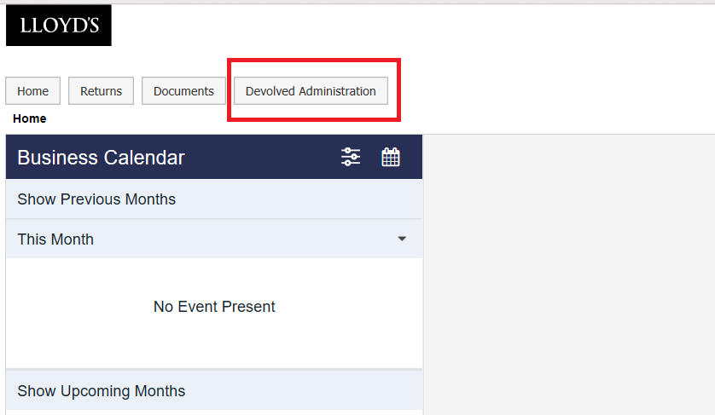

- Select the user you wish to edit by clicking on “Edit” next to their name

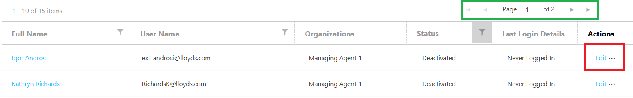
You may have multiple pages of users, you can cycle through the pages of users using the page buttons circled in green.
- Once in the user edit screen scroll to the bottom of the page and select in the tick boxes which syndicates they require access to.

- Once a syndicate has been selected an “Access Roles” button will appear.
- Click on the “Access Roles” button

A pop out window will appear with a list of access roles available

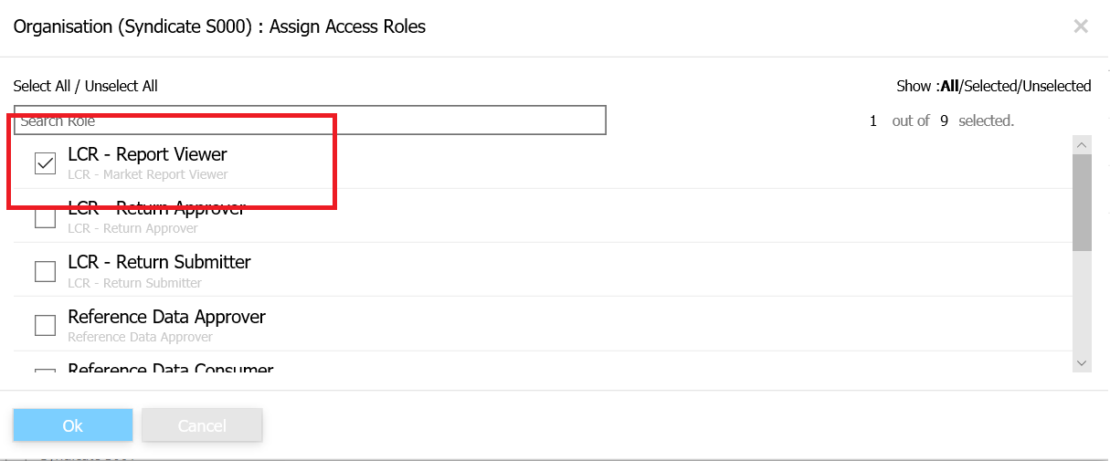

- Selected which access roles you require the user to have (more than one access roles can be selected), then click “OK”

- You will be returned to the previous screen where you should then click “Activate”

The user now is in an active user with the correct permissions.

