AXIS Corporate Capital UK Limited
Represented by Albert A.Benchimol

Elected C-External Member

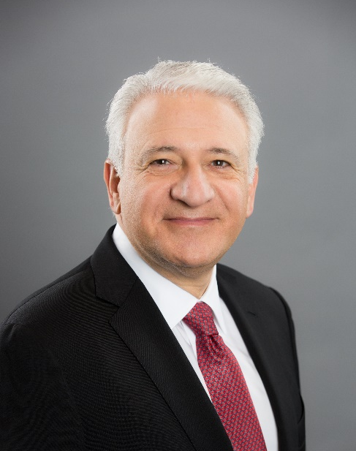
Statement

My career in financial services spans 36 years, including banking, non-life insurance and life and non-life reinsurance in the US, Canada, Latin America, Bermuda, the United Kingdom, Ireland, Continental Europe, Dubai, Singapore and Australia.

My roles have included finance (Treasurer / Chief Financial Officer), governance (director of public and private companies) and strategy and management (Chief Executive Officer) for companies based in Montreal, New York and Bermuda.

I have engaged with the Lloyd’s market throughout my career, and more directly since the authorisation in 2013 of Syndicate 1686, which commenced underwriting in 2014 under management by Asta Managing Agency Limited. AXIS Managing Agency was authorised in 2017, following which it has managed AXIS Syndicate 1686.

In October 2017, AXIS acquired all of the issued share capital of Novae Group plc - an acquisition which advanced AXIS’ strategy to hold leadership positions and relevance in each of the specialty risk markets in which it competes. Further, the acquisition demonstrated the commitment of AXIS to London and Lloyd’s as the pre-eminent market for specialty risks. Novae’s legacy Lloyd’s syndicate, Syndicate 2007, was merged into AXIS Syndicate 1686 as at 1 January 2019.

I have often spoken publicly about my commitment to the success of Lloyd's and the London specialty re/insurance market as a whole, and as a member of Council, my particular areas of focus would include the following to help secure that success:

Strategy - supporting newly appointed CEO John Neal and his Executive in formulating Lloyd’s strategy, in particular bringing my experience in organisational transformation and my knowledge of the global re/insurance marketplace to bear on Lloyd’s to ensure it remains the pre-eminent market for specialty risks;

Profitability - supporting the market’s return to sustainable profitability;

The insurance ‘gap’ - assisting Lloyd’s in bridging the gap between economic loss and insured loss and developing new products to support rapidly changing customer needs;

Market modernisation and London Target Operating Model - supporting Lloyd’s in the development of its Innovation Lab, its step change in use of technology, and the development of data and analytics capability to enhance risk selection and market performance; and

Capital markets and alternative capital - ensuring Lloyd’s leads in its use of alternative capital to optimise its operating platform for the benefit of Policyholders, Members and the Corporation.

I look forward to the opportunity to serve Lloyd’s and contribute to its success.

